INTRACARDIAC MASS IN CHRONIC MYELOID LEUKAEMIA
Dr Chetana Krishnegowda
Assistant professor, Department of Cardiology, Sri Jayadeva Institute of Cardiovascular Sciences and Research, Bangalore, India

Abstract
The advent of tyrosine kinase inhibitors has dramatically changed the outlook for patients with CML. However, they remain at a high risk of thrombotic complications and bleeding amounting to increased mortality.There are no large-scale studies available for guiding appropriate anticoagulation therapy and management of complications. Differentiating an intracardiac thrombus from vegetation and chloroma in these patients by multimodality imaging and initiation of appropriate treatment are vital in reducing the overall morbidity and mortality. Herein we describe a rare case of CML presenting with an intracardiac thrombus attached to the posterior mitral leaflet, and subsequently resulting in peripheral embolisation.

Image

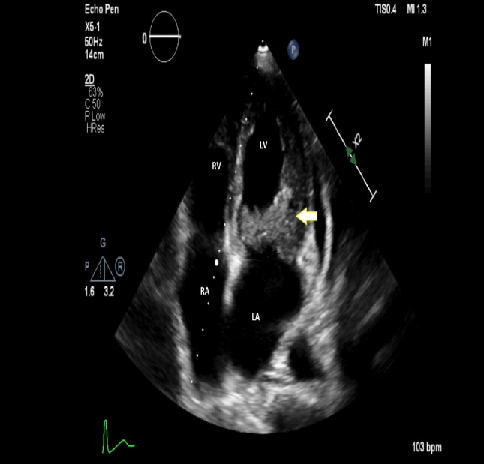

Recent Publications

1. Kharwar RB, Sharma K, Jain S. Acute Myeloid Leukemia with Intracardiac Thrombus
Presenting as Acute Limb Ischemia. J Cardiovasc Ultrasound 2016;24(2):174-176
2. Timonen TTT, HakalaM, Syrjälä H . Serious ReversibleThrombotic Complications of
Thrombocytosis in Myeloid Leukaemia. Platelets 2015 ; 53-55
3. Upadhyay et al. Chloroma (Granulocytic sarcoma): An unusual cause of shoulder pain
in chronic myeloid leukemia;a diagnostic dilemma. Journal of Orthopedics and Allied
Sciences 2014, Vol 2; 20-23
4. Kim JG, Moon D, Youn HJ et al. Recurrent cardiac chloroma presenting as acute chest
pain. Q J Med 2014; 107:381–382

Biography



Dr Chetana has been trained in interventional cardiology at one of the largest cardiac care destinations in South East Asia and is competent in independently performing coronary angiograms and angioplasties. She also has passion towards clinical cardiology and non-invasive cardiology (including cardiac imaging). She has several publications and international case presentations including TCT 2018.

Notes/Comments:

This is the first report to our knowledge of intracardiac thrombus in CML and this case highlights the role of cardiac imaging in guiding appropriate management. The images are striking and illustrative and we believe this will be of interest to the audience.

