Inhibitory effect of 2-Aminoethyl diphenyl borinate (2-APB) on over expression of STIM1 and Orai1 in isoproterenol induce acute myocardial infarction in rats

Hardik H. Savsani, M.pharm, Department of Pharmacology, Faculty of Pharmacy, The Maharaja Sayajirao University of Baroda, Vadodara-390001, Gujarat, India
Dr. Kirti V. Patel, Ph.D, Department of Pharmacology, Faculty of Pharmacy, The Maharaja Sayajirao University of Baroda, Vadodara-390001, Gujarat, India

Abstract
Statement of the Problem: Cardiovascular diseases (CVD) are the major cause of mortality globally, nationally and regionally. 80% of all CVD deaths are due to heart attacks and strokes. Current medical therapies for myocardial infarction (MI) can improve clinical symptoms and slow the progression of contractile dysfunction and expansion of LV chamber volume, nevertheless, there is still progression, and poor prognosis for even the optimally treated patient. Changes in calcium homeostasis during MI is to be attributed mainly to the energy ‘crisis’ and reactive oxygen species. However, the molecular mechanisms of store operated calcium entry (SOCE) hidden under MI remain unknown. This demands serious attention to unravel the molecular mechanisms to identify the therapeutic strategies either to prevent or to control MI.
Methodology: Isoproterenol (ISO) induced MI [by administration of first dose of ISO (85 mg/kg, S.C) on 1st day of study followed by second dose of ISO after 24 hours] model was used to study the effect of 2-APB (4 mg/kg) administered on 12 h interval for 2 days before ISO injection in male wistar albino rats (250 ± 30 gm). Electrocardiography and hemodynamic analysis was done at the end of study. Biological specimens were collected and used for the estimation of various cardiac biomarkers, antioxidants, ATPase and SOCE protein expression (STIM1 and Orai1).
Findings: 2-APB improved left ventricular pressure, normalized echocardiography, cardiac biomarkers, antioxidant status and reduced expression of STIM1 and Orai1, thus prevent ISO induced MI.
Conclusion & Significance: Cardio protective action of 2-APB can be attributed to modulation of calcium through SOCE inhibition.

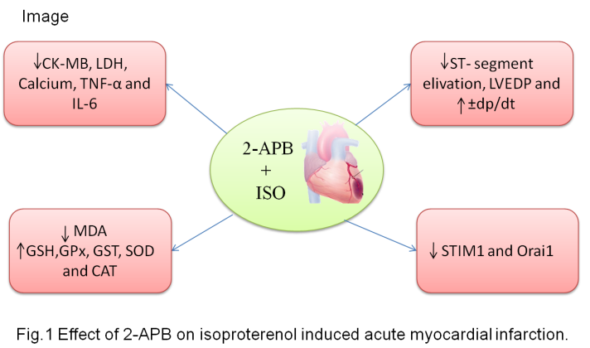
Recent Publications
- Roth, G.A., Johnson, C., Abajobir, A., Abd-Allah, F., Abera, S.F., Abyu, G., Ahmed, M., Aksut, B., Alam, T., Alam, K., 2017. Global, regional, and national burden of cardiovascular diseases for 10 causes, 1990 to 2015. Journal of the American College of Cardiology 70, 1-25.
- Gorski, P.A., Ceholski, D.K., Hajjar, R.J., 2015. Altered myocardial calcium cycling and energetics in heart failure—a rational approach for disease treatment. Cell metabolism 21, 183-194.
- Luo, X., Hojayev, B., Jiang, N., Wang, Z.V., Tandan, S., Rakalin, A., Rothermel, B.A., Gillette, T.G., Hill, J.A., 2012. STIM1-dependent store-operated Ca2+ entry is required for pathological cardiac hypertrophy. Journal of molecular and cellular cardiology 52, 136-147.
- Tasatargil, A., Kuscu, N., Dalaklioglu, S., Adiguzel, D., Celik-Ozenci, C., Ozdem, S., Barutcigil, A., Ozdem, S., 2017. cardioprotective effect of nesfatin-1 against isoproterenol-induced myocardial infarction in rats: Role of the Akt/gsk-3β pathway. Peptides 95, 1-9.
- Yildar, M., Aksit, H., Korkut, O., Ozyigit, M.O., Sunay, B., Seyrek, K., 2014. Protective effect of 2-aminoethyl diphenylborinate on acute ischemia–reperfusion injury in the rat kidney. journal of surgical research 187, 683-689.

Biography

Hardik H. Savsani completed his B.Pharmacy degree in 2011 and postgraduation in Pharmacology in 2013 from Gujarat Technology University, Ahmadabad, India. He joined department of toxicology as junior research officer at Jai Research Foundation in 2013. He joined the research group of Dr. Kirti V. Patel in 2015 for pursuing his doctoral studies in Pharmacy at Faculty of Pharmacy, The Maharaja Sayajirao University of Baroda, Vadodara, Gujarat, India. He has been awarded with research fellowship from MSU, Gujarat and has one publication to his credit in reputed peer-reviewed journals.


Dr. Kirti V. Patel joined department of pharmacology, Anand Pharmacy College, Anand in 1999.She is currently working as Associate professor at Faculty of Pharmacy, The Maharaja Sayajirao University of Baroda, Vadodara from 2013. She has about 19 years of research experience with more than 43 peer-reviewed national and international research/review articles, one book and one Indian patents to her credit. Her area of research work includes biochemical and molecular cardio pharmacology, oncology, neuropharmacology, inflammatory disease. One student has been awarded Ph.D. under her supervision. Presently four Ph.D. research scholars are working under her supervision.

Email: hardik_savsani@rediffmail.com

