Investigation of a Scabies Outbreak in
Drought-Affected Areas in Ethiopia
Wendemagegn Enbiale, Dermatology and Venerology, Bahir Dar University, , Bahir Dar, Ethiopia
Ashenafi Ayalew, Amhara Regional Health Bureau, Amhara, Ethiopia

Abstract: In 2015, Ethiopia faced a scabies outbreak in drought-affected areas where there was a shortage of safe water for drinking and personal hygiene. Following the outbreak report, training was provided on scabies identification and management. Screening and management guidelines and protocols were also distributed. House-to-house data collection was undertaken by 450 health extension workers (HEWs) to assess the prevalence of scabies. Subsequently, data were collected by dermatologist and validated in two zones and six woredas from 474 participants who had been diagnosed with scabies using a standardized questionnaire. This was designed to look at the specificity of the diagnosis of scabies, age distribution, severity, duration of illness and secondary infection. The HEWs screened 1,125,770 people in the 68 districts in Amhara Region and a total of 379,000 confirmed cases of scabies were identified. The prevalence in the different districts ranged from 2% to 67% and the median was 33.5% [interquartile range (IQR) 19–48%]. 49% of cases were school-aged children. The detailed study of 474 individuals who were recorded as scabies cases revealed that the specificity of the diagnosis of scabies by the HEWs was 98.3%. The mean duration of illness was 5 months (SD of ± 2.8). One third of patients were recorded as having severe illness, 75.1% of cases had affected family members, and 30% of affected children were noted to have secondary bacterial infection. Eleven percent of the students had discontinued school due to scabies or/and drought and 85% of these had secondary bacterial infection. These community-based data serve as reliable proxy indicators for community-based burden assessment of the scabies epidemic. This study will also provide a good basis for advocating the use of a community-level clinical diagnostic scheme for scabies using an algorithm with a simple combination of signs and symptoms in resource-poor settings.

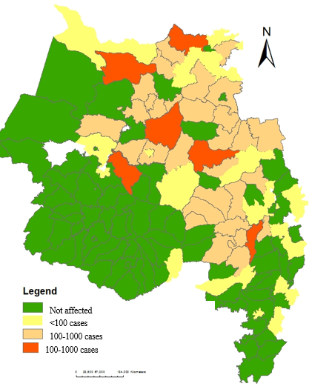
Figure 1. Scabies distribution in in Amhara Region, Ethiopia (2015–2016).
Recent Publications
- Ugbomoiko, U.; Oyedeji, S.; Babamale, O.; Heukelbach, J. Scabies in resource-poor communities in Nasarawa State, Nigeria: Epidemiology, clinical features and factors associated with infestation. Trop. Med. Infect. Dis. 2018, 3, 59, doi:10.3390/tropicalmed3020059.
- World Health Organization. Epidemiology and Management of Common Skin Diseases in Children in Developing Countries; WHO: Geneva, Switzerland, 2005. Available online: whqlibdoc.who.int/hq/2005/WHO_FCH_CAH_05.12_eng.pdf (accessed on 23 July 2018).
- WHO. El Nino and Health; WHO Report 2016; WHO: Geneva, Switzerland, 2016. Available online: who_el_nino_and_health_global_report_21jan2016.pdf (accessed on 4 June 2017).
- EM-DAT: The OFDA/CRED International Disaster Database; Universite Catholique de Louvain: Brussels, Belgium. Available online: http://www.emda.be/result-disaster-profiles?disgroup=natural&period=1900%242012&dis_type=Drought&Submit=Display+Disaster+Profile (accessed on 4 June 2017).
- Scabies Outbreak Preparedness and Response Plan; FMOH: Addis Ababa, Ethiopia, 2015. Available online: www.humanitarianresponse.info (accessed on 23 July 2018).

Biography
Wendemagegn Enbiale, Associate professor of dermatovenerology and public health professional in Bahir Dar University Ethiopia. Have been working on Skin NTD for the last 10 years. He is also advisor for the regional health bureau and Federal Ministry of Health in Skin NTD's. In the last 3 years he is leading the scabies response in Ethiopia Amhara region.
Email:wendemagegnenbiale@gmail.com

