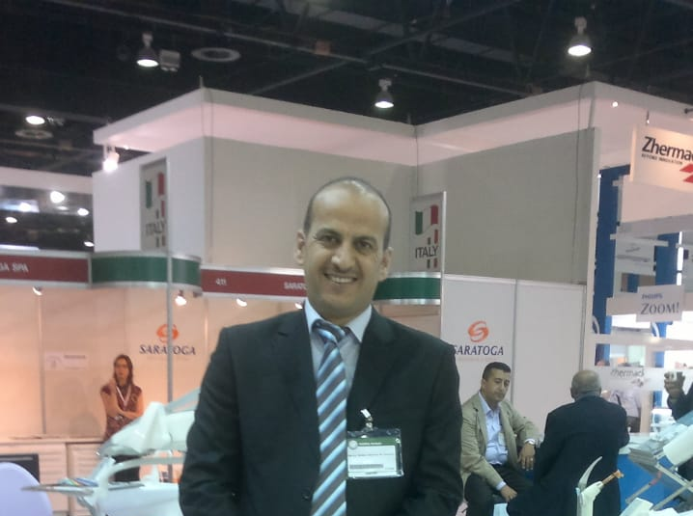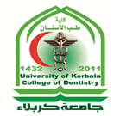

Bone-borne accelerated sutural expansion: An experimental study
Akram S. Alyessary, BDS, MSc, PhD, Iraq; Adrian U. J. Yap, BDS, MSc, PhD, Graduate Diploma Psychotherapy, Singapore; Siti A. Othman, BDS, DDS, MOrthRCSEd, MOrthRCS Ad Eundem, Malaysia; Mohammad T. Rahman, BSc, MSc, PhD, Malaysia and Zamri Radzi, DDS, FFDRCSI, MOrth RCSEd, MOrth RSCEng, MDent Sci, MSc, PhD, Malaysia.

Abstract

Objective: The present study investigated the effect of piezoelectric sutural ostectomies on accelerated bone-borne sutural expansion.

Materials and Methods: Sixteen male New Zealand white rabbits (20 to 24 weeks old) were randomly divided into 4 experimental groups (n = 4): group 1, conventional rapid sutural expansion; group 2, accelerated sutural expansion; group 3, accelerated sutural expansion with continuous ostectomy; and group 4, accelerated sutural expansion with discontinuous ostectomy. All sutural ostectomies were performed using a piezoelectric instrument (Woodpecker DTE, DS-II, Guangxi, China) before expander application with the rabbits under anesthesia. Modified hyrax expanders were placed across the midsagittal sutures of the rabbits and secured with miniscrew implants located bilaterally in the frontal bone. The hyrax expanders were activated 0.5mm/day for 12 days (group 1) or with a 2.5-mminitial expansion, followed by 0.5mm/day for 7 days (groups 2 to 4). After 6 weeks of retention, the bone volume fraction, sutural separation, and new bone formation were evaluated using micro-computed tomography and histomorphometry. Statistical analysis was performed using Kruskal-Wallis and Mann-Whitney U tests and Spearman’s rho correlation (P < .05).

Results: Ranking of the median sutural separation was as follows: group 1, 3.05 mm; group 2, 3.97 mm; group 4, 4.78 mm; and group 3, 5.66 mm. The least and most bone formation were observed in groups 1 (63.63%) and 3 (75.93%), respectively. Spearman’s correlation showed a strong, positive, and significant correlation (r = 0.932; P < .01) between the new sutural bone formation and amount of sutural separation.

Conclusions: Piezoelectric sutural ostectomies increased the rate of sutural separation and promoted new sutural bone formation/osteogenesis. Continuous ostectomy gave better results than discontinuous ostectomy.
Key words: Piezoelectric, ostectomy, sutural expansion, bone separation, bone formation.

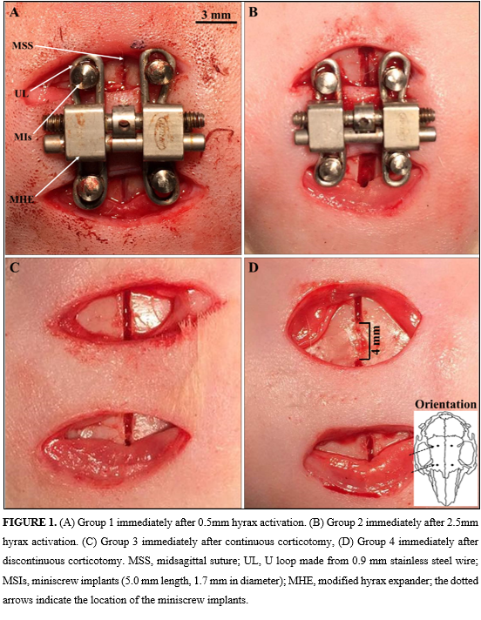
Recent Publications
1. Alyessary AS, Yap AU, Othman SA, Rahman MT, Radzi Z. Effect of piezoelectric sutural ostectomies on accelerated bone-borne sutural expansion. Journal of Oral and Maxillofacial Surgery. 2018;76(3):616-30.
2. Alyessary AS, Othman SA, Yap AU, Radzi Z, Rahman MT. Effects of non-surgical rapid maxillary expansion on nasal structures and breathing: A systematic review. International orthodontics. 2019;17(1):12-9.
3. Alyessary AS, Yap AU, Othman SA, Ibrahim N, Rahman MT, Radzi Z. Bone-borne accelerated sutural expansion: A microcomputed tomography study in rabbits. American Journal of Orthodontics and Dentofacial Orthopedics. 2018;154(2):260-9.
4. Alyessary AS, Yap AU, Othman SA, Rahman MT, Al-Namnam N, Radzi Z. Is there an optimal initial amount of activation for midpalatal suture expansion? Journal of Orofacial Orthopedics/Fortschritte der Kieferorthopädie. 2018;79(3):169-79.

Biography
I am an Orthodontist senior lecturer at the College of Dentistry / University of Kerbala (Iraq). I received my Bachelor of Dental Surgery from the University of Baghdad in 2004. My dental training was in Baghdad (College of Baghdad / Teaching Hospital) and in Kerbala (Iraqi Ministry of Health / Specialized Dental Center). I was awarded an MSc in Orthodontics in 2010 from the University of Baghdad and then I was a senior (clinical orthodontist) at Iraqi Ministry of Health / Specialized Dental Center for two years. I have treated more than 1000 patients with malocclusion by using fixed and removable orthodontic appliances. After that, I was appointed to University of Kerbala as a senior lecturer and researcher in 2012. I was awarded an PhD in Orthodontics in March 2018 from the University of Malaya (Malaysia). My main research interests are in transverse maxillary deficiency, accelerated maxillary expansion protocols, piezoelectric sutural osteotomy, 3D imaging analysis, experimental animal research and the delivery of clinical care by orthodontists.

Akram Shaker Hussein Alyessary
University of Kerbala
Assistant Professor Doctor
Iraq
Mobile number: 009647819382165
Email: akram.sh@uokerbala.edu.iq
Track number: 5-8
Category: Oral presentation.
Research interest: Transverse maxillary deficiency, accelerated maxillary expansion protocols, piezoelectric sutural osteotomy, 3D imaging analysis, experimental animal research and the delivery of clinical care by orthodontists.

