Abstract Title: IMPLANT-ASSISTED OVERDENTURES; A PARADIGM RELOCATION & SIMPLIFICATION...
MOSTAFA HELMY MOSTAFA AHMED

¹ First Author Affiliation (FACULTY OF DENTISTRY-CAIRO UNIVERSITY-EGYPT.)

Abstract (not more than 300 words)

Completely edentulous patients often have problems with their complete dentures; a treatment modality of using two, four or six implants to support an overdenture has been proposed to improve the retention as well as the stability of the conventional denture, in addition to preserving the residual alveolar bone. Several worldwide research studies tested the impact of implant-assisted overdentures on satisfaction and quality of life and concluded that; individuals with implant-assisted overdentures were more satisfied and had a better oral health quality than others with conventional dentures.
Implant-supported overdentures are indicated in clinical conditions requiring high values of retention and stability; such as cases of high muscle attachments.
Implant-retained overdentures offered a simpler, cheaper and equally successful prosthetic solution compared to the fixed restorations in the rehabilitation of maladapted edentulous mandibles. Moreover, they provide enhanced masticatory function, higher patients' satisfaction and quality of life than the conventional complete dentures.

Keywords— Implants, Overdentures, Pick-up, Retention.

Professional Biography (100-150 words)

PhD (DOCTOR degree) in IMPLANT_ PROSTHETIC DENTISTRY – Kasr El Aini - Cairo University 2013.

M.Sc. (MASTER degree) in IMPLANT_ PROSTHETIC DENTISTRY – Kasr El Aini - Cairo University since 2010.

Lecturer in PROSTHETIC DEPARTMENT –CAIRO UNIVERSITY since 2013 till now.

Ass. Lecturer in PROSTHETIC DEPARTMENT –CAIRO UNIVERSITY since 2010 till 2013.

Demonstrator in PROSTHETIC DEPARTMENT –CAIRO UNIVERSITY since 2007 till 2010.

RESIDENT IN PROSTHETIC DEPARTMENT –CAIRO UNIVERSITY since 2004 till 2007.
- UNIVERSITY: BA degree from the Faculty of Dentistry year 2002,

Advanced training activities
Kasr EL-Aini, Cairo University- Egypt with grade “EXCELLENT WITH HONORS”.

- DIPLOMATE IN DENTAL IMPLANTS 2003, Ain Shams University with 208 credit hours.
- Lots of Advanced courses in dental implantology.
- Membership in ICOI, DGOI, ESOR, ESSDI.
- Fellowship of ICOI.2008
- Mastership of ICOI.2012
- DIPLOMATE OF ICOI 2016.
- Well familiar with all of dental implant systems.
- Performing up to 5000 cases of implants with different treatment modalities.
- Performing up to 500 cases of maxillofacial prosthesis with different treatment modalities.
- Attendance all dental conferences held in Egypt since 1998.
- Attendance of many dental conferences held outside Egypt.
- Having a lot of courses in all branches of Advanced Dentistry.
- An International Speaker in Many World-wide Conferences:
- Greater New-York Meeting.
- African Congress of Dentistry & Implantology (ACDI).
- AEEDC-Dubai.
- Academy of Osseointegration-San Diego.
- ICOI Annual Meeting-Barcelona-Spain.
- Bioleagues dentistry & oral health summit.
- FDI annual meeting-Poland
- Published more than 10 international papers in reputed journals.

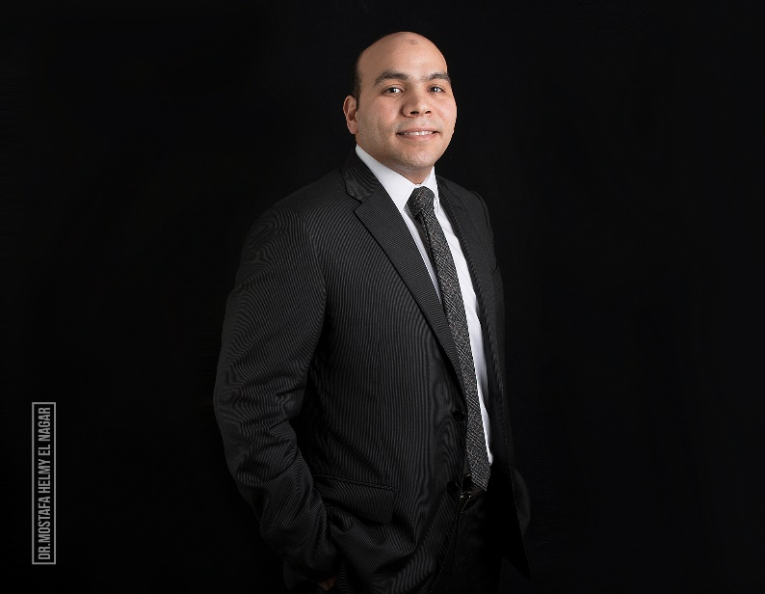
Paste your Photograph here

Name: MOSTAFA HELMY MOSTAFA AHMED
Email: dr.mostafahelmy@hotmail.com
mostafa.helmy@dentistry.cu.edu.eg
Number: 00201001817812

