Antibacterial activity evaluation of cationic surfactants in the series of (N-(n-hydroxyalkyl)-N, N- dimethyl n-alkyl ammonium bromide): A theoretical approach by the docking study.
Zakaria Hafidi¹, Mohammed El Achouri¹, Lamia Yakkou², Fatima-Ezzahra guouguaou¹, Souad Amghar², S.Amghar

¹ Mohammed V University in Rabat, Laboratoire de physico-chimie des matériaux inorganiques et organiques, Centre des Sciences des Matériaux, Ecole Normale supérieure-Rabat, Morocco.
² Research Team: « Lumbricidae, Improving Soil Productivity and Environment » (LAPSE). Centre « Eau, Ressources Naturelles, Environnement et Développement Durable (CERN2D) ». Ecole Normale Supérieure- University Mohamed V in Rabat.

Abstract

Some quaternary ammonium from amino-alcohols and n-bromoalkanes, referred to as C₁₄EtOH, C₁₄PrOH and C₁₄iPrOH, (where EtOH = ethanol, PrOH = propanol, iPrOH= iso-propanol) have been synthetized. Their structures were checked by the usual spectroscopic methods (¹H, ¹³C NMR and IR and RX) and their physicochemical properties in aqueous solution have been studied by surface tension and conductivity measurements.
The assessment of their antibacterial activity in water was made against 3 bacterial strains Escherichia coli (E. Coli), Staphylococcus aureus (S. Aureus), and Pseudomonas aeruginosa (P.Aerug). The values of Inhibition Zone (IZ), Minimum Inhibitory Concentration (MIC) and Minimum Bactericidal Concentration (MBC) were evaluated in terms of two structural factors such as the lengthening of the hydrophobic chain carbon atoms and the location of OH alcoholic function with respect to quaternary ammonium, N⁺. The location OH group shows its influence on the availability of N⁺ which is responsible for the electrostatic interactions with bacterial cell walls.
The theoretical binding mode of the target molecules was evaluated by docking studies against the enzyme Dehydrosqualene synthase (CrtM) (PDB = 3ACX). The DFT method was made to understand the effect of the degree of molecular electrophilicity in the inhibition process of three types of cationic surfactants against two bacterial strains Gram-negative types Escherichia coli (E. coli) and Pseudomonas aeruginosa (Pseudo).
The membrane surface of Gram-positive bacteria is generally negatively charged due to the presence of lipopolysaccharide group, therefore a number of descriptors were calculated by of B3LYP / 6 -31 G (d) method for the three inhibitors in their monomer state (below CMC(critical micellar concentration) in the aqueous medium, the examination of these descriptors reveals that the C₁₄EtOH molecules is the best inhibitor which has an ability to accept an electron from the bacterial walls negatively charged following the C₁₄IPrOH and C₁₄PrOH.

Keywords— Cationic Surfactants - Quaternary Ammonium - Antibacterial activity - Molecular docking- Dehydrosqualene - 3ACX – Aminoalcohols- DFT- Electrophilicity.

Professional Biography

Zakaria Hafidi has a bachelor’s from Ibn Zohr University of Agadir and an M.Sc. from Mohammed V University of Rabat. He is currently preparing her doctorate in organic chemistry: Synthesis of new quaternary ammonium surfactants and their potential use.
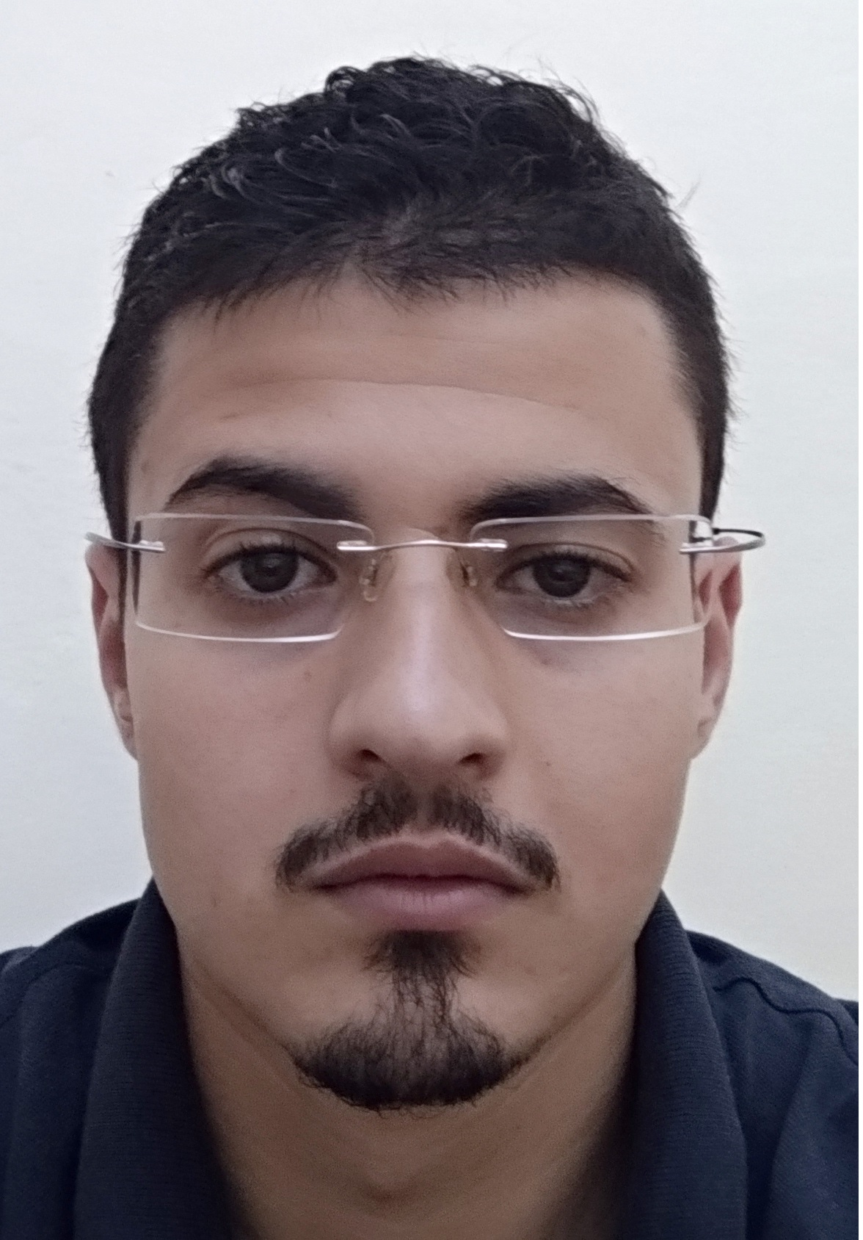

Email Id: zakariahafidi21@gmail.com

