Addressing the Opioid Crisis by Developing Analgesic Drugs

With Novel Modes of Action

Sylvie DUCKI¹

¹ Université Clermont Auvergne, Sigma Clermont, Institut de Chimie de Clermont-Ferrand, BP10448, 63000 Clermont-Ferrand, FRANCE

Chronic pain affects 1.5 billion people worldwide, causing a great deal of discomfort among patients and an enormous economic and socetial burden. Inadequate pain control, undesirable side-effects associated with current analgesics as well the recent opioid crisis have revived interest in analgesic drug development. The challenge is to develop original analgesics with novel modes of action to address the unmet needs of patients.
Pichon recently reported that disrupting the interaction between the PDZ-containing protein PSD-95, and the endogenous ligand 5-HT_{2A} receptor, reduced hyperalgesia suggesting inhibition of this PDZ protein could result in analgesia.
Devilliers reported that TWIK-Related K⁺ channel TREK-1 -/- mice were more sensitive than wild-type TREK-1 +/+ mice to painful stimuli, suggesting that activation of TREK-1 could result in pain inhibition.
Various approaches of drug discovery were explored in order to develop original analgesic drugs targeting PSD-95 and TREK-1.
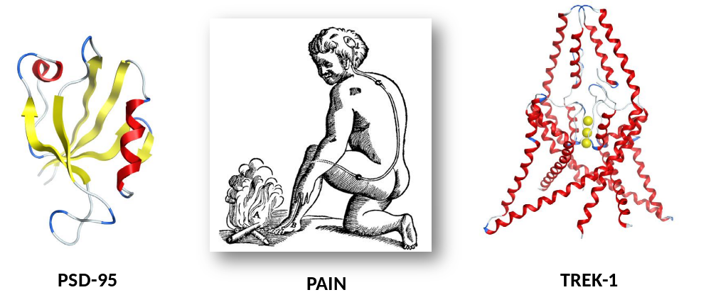

Keywords — Analgesia, Medicinal Chemistry, PSD-95 protein, TREK-1 channel

Professional Biography (100-150 words)

Sylvie DUCKI has completed her PhD at the age of 25 from the University of Manchester (UK) and postdoctoral studies at the Arizona State University (USA). She joined the University of Salford for a 6-year lectureship and has been a professor in Organic and Medicinal Chemistry at SIGMA Clermont (FRANCE) for 11 years. Sfe has published more than 60 papers in reputed journals and has been serving as an editorial board member of various journals including Anti-Cancer Agents in Medicinal Chemistry, Current Chemical Biology, Medicinal Chemistry.


Sylvie.Ducki@Sigma-Clermont.fr

