Abstract Template
Abstract Title: Bare eye detection based on gold nanoparticles as alternative for traditional analytical methods
Essy Kouadio Fodjo,¹* Cong Kong² and Koffi Mouroufié Gabriel³

¹Laboratory of Physical Chemistry (Université Felix Houphouet-Boigny, 22 BP 582 Abidjan 22, Cote d’Ivoire)
²East China Sea Fisheries Research Institute (Chinese Academy of Fishery Sciences, No. 300, Jungong Road, Yangpu, Shanghai 200090, PR China)
³Laboratoire des Procédés Industriel et de Synthèse de L'Environnement (Institut National Polytechnique Felix Houphouet-Boigny, BP 1093 Yamoussoukro, Cote d’Ivoire)

Abstract

Since the traditional analytical techniques are costly and need trained staff, research is focused on the development of easy analytical methods in order to overcome the increase in needs especially in food security. For this purpose, there are several reports aiming to improve these methods or explore novel strategies for its product detection. Gold nanoparticles (AuNPs) can be functionalized with biology compounds (streptavidin, Avidin-AuNPs for instance), and designed to signal for a selective contaminant detection. Most of these complexes can cause clusterization of biology compound-AuNPs and leads to a color change of the solution from red to blue (Figure). This visual detection scheme which does not require any fluorescent reagents and detection instruments can hold promise in point of care and food testing, particularly in resource-limited regions.

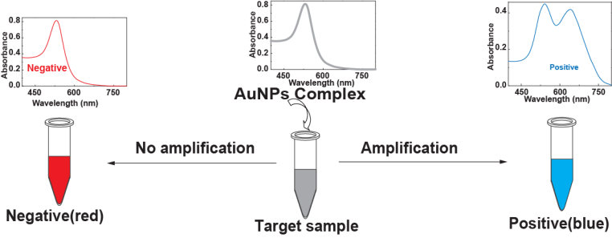

Keywords— Contaminants, Food Chemistry, Gold nanoparticles, Visual detection

Professional Biography

Dr. ESSY Kouadio Fodjo received his Ph.D. degree (2013) in analytical chemistry under the supervision of Prof. Yitao LONG from East China University of Science and Technology (Shanghai, China). After his PhD, he has been awarded as visiting Scientist at Abdullah Gull University by TUBITAK (Turkey) in Analytical Chemistry based on Nanotechnology. Actually, he acts as project leader supported by Third World Academy of Sciences (TWAS) which entitled “Selective-Size Synthesis of Silver Nanomaterials AgAu_{x}(Fe₃O₄)_{y}” under the Research Grant N° 16-510 RG/CHE/AF/AC_G–FR3240293301. For all, Dr. ESSY’s research is mainly focused on Analytical Chemistry based on Nanotechnology, background built after years of experience in research, evaluation and, teaching both in study tours and education institution (Felix HOUPHOUET-BOIGNY University). Currently, Dr. ESSY has published more than 20 papers in reputed journals such as Journal of Materials Chemistry, Materials Chemistry and Physics and, Applied Surface Science.



Email Id: essykouadiofodjo@yahoo.fr

Any Comments: A neo-formed food contaminants detection using bare eye detection based on gold nanoparticles is an important project in collaboration with the three above institutions (UFHB, ECSFRI and INPHB).

