Computer Aided Shoulder Prosthesis
Design and Manufacturing
D. V. Yıldız, Izmir Vacotional School, Dokuz Eylül University
M. Dursun, Metum, University of Health Sciences
M. Hocaoglu, Mechanical Engineering Department, Dokuz Eylül University
T. Akkan, Izmir Vacotional School, Dokuz Eylül University

Abstract
The shoulder joint is a more complex structure than the hip or knee joints. In addition to the overall complexity of the shoulder joint, two different factors influence the insufficient outcome of shoulder replacement: the shoulder prosthesis design is far from fully developed and it is difficult to place these shoulder prosthesis due to shoulder anatomy.
The glenohumeral joint is the most complex joint of the human shoulder. There are various treatments for shoulder failures such as total shoulder arthroplasty, reverse total shoulder arthroplasty. Due to its reverse design than normal shoulder anatomy, reverse total shoulder arthroplasty has different physiological and biomechanical properties. Post-operative achievement of this arthroplasty is depend on improved design of reverse total shoulder prosthesis. Designation achievement can be increased by several biomechanical and computational analysis.
Figure 1 : A. Von Misses Equivalent Stress Distribution for Intact Shoulder
Model
B. Von Misses Equivalent Stress Distribution for Prosthetic Shoulder

In this study, data of human both shoulders with right side fracture was collected by 3D Computer Tomography (CT) machine in dicom format. This data transferred to 3D medical image processing software (Mimics Materilise, Leuven, Belgium) to reconstruct patient’s left and right shoulders’ bones geometry. Provided 3D geometry model of the fractured shoulder was used to constitute of reverse total shoulder prosthesis by 3-matic software. Finite element (FE) analysis was conducted for comparison of intact shoulder and prosthetic shoulder in terms of stress distribution and displacements. Body weight physiological reaction force of 800 N loads was applied. Resultant values of FE analysis was compared for both shoulders.
The analysis of the performance of the reverse shoulder prosthesis could enhance the knowledge of the prosthetic design.

Image
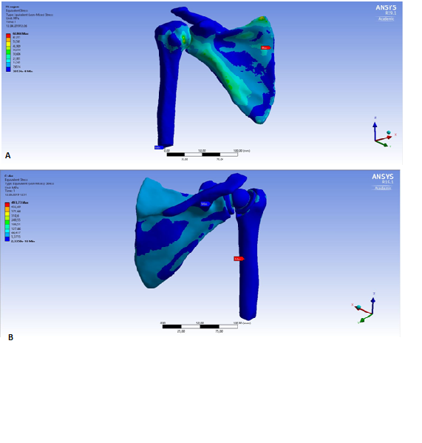

Recent Publications
- D. Konar, M. Devarasetty, D. V. Yildiz, A. Atala & S. Murphy (2016) Lung-On-AChip Technologies for Disease Modelingand Drug Development, Biomedical Engineering and Computational Biology 7, S1, 17-27.
- A. A. Karaarslan, A. Karakasli, H. Aycan, D. V. Yildiz, E. Sesli (2016) The best location for proximal locking screw for femur interlocking nailing A biomechanical study, Indıan Journal of Ortohaepedics 50, 1, 94-98.
- M. Erduran, A. Karakasli, L. Baktiroğlu, D. V. Yildiz, A. Budeyri & H. Havitçioglu (2015) The effects of tibiofibularis anterior ligaments on ankle joint biomechanics. Ulusal Travma Acil Cerrahi Dergisi 21, 2, 90-95.
- A. Karakaşli, D. V. Yildiz, E. Kumtepe, C. Kizmazoğlu, H. Havitçioglu (2013) Biomechanical comparison of intact lumbar lamb spine and endoscopic discectomized lamb spine. Joint Diseases & Related Surgery 24, 1, 33-38.
- A. Karakaşli, D. V. Yildiz, C. Kizmazoğlu & H. Havitçioglu (2013) Biomechanical Comparison Of Intact Lumbar Lamp Spine And Endoscopic Discectomized Lamp Spine. Eklem Hastalık Cerrahisi 24(1):33-38
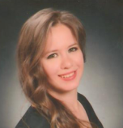

Biography
Didem Venüs Yıldız has her expertise in bioengineering, organ engineering and biomechanics. She does research in Orthopedic Surgery, Bioengineering/Biomedical Engineering. xperienced PHD with a demonstrated history of working in the higher education industry. Skilled in Research and Development (R&D), Medical Devices, Life Sciences, Data Analysis, and Organ Engineering. Strong professional with a Bioengineer focused in Tissue Engineering, Biomedical Engineering from Ege Üniversitesi. xperienced PHD with a demonstrated history of working in the higher education industry. Skilled in Research and Development (R&D), Medical Devices, Life Sciences, Data Analysis, and Organ Engineering. Strong professional with a Bioengineer focused in Tissue Engineering, Biomedical Engineering.
Email: didemvenusy@yahoo.com
Notes/Comments

