Silk proteins as biomaterial templates in tissue engineering of the eye

Traian V. Chirila, BEng, PhD, DHC, CChem, FRACI, FRSC
Queensland Eye Institute, Brisbane, Australia

The field of ophthalmic biomaterials has become firmly established as an integral and essential part of ocular tissue engineering and regenerative ophthalmology. Beyond prosthetic replacements or devices, novel ophthalmic biomaterials are being developed where their bulk structure and /or surface are manipulated chemically or biochemically. Amongst such materials, fibroin and sericin–the main polypeptidic components of the silk produced by the larvae of domesticated silk moth (Bombyx mori)–have been investigated as potential biomaterials for a range of applications. The purpose of this keynote presentation is to describe the research and developmental work on silk fibroin (BMSF) and silk sericin (BMSS) carried out over the past decade in the author’s laboratory. The aim of our work was to promote and assess these proteinaceous materials as biomaterials for the tissue engineering of the eye. The silk proteins present a series of desirable properties: can be processed into a variety of forms, are not cytotoxic, elicit low immune response, are permeable for fluids and biomolecules, and degrade protractedly in physiologic media without accumulation of debris. The feasibility of utilizing silk proteins as materials for reconstructing tissues of clinical significance in the human eye was reported for the first time by our group, when we demonstrated that primary human corneal epithelial cells attach and proliferate on BMSF membranes at levels comparable to those observed on traditional substrata. Subsequent work has established BMSF as a functional substratum of significant potential in ocular tissue engineering. Our work extended to BMSS, to the fibroin produced by a wild silk moth, and to modified BMSF. We have reported extensively on the evaluation of silk proteins as substrata for corneal cells (epithelial, limbal epithelial, limbal mesenchymal stromal, endothelial), and retinal pigment epithelial cells.
The author’s gratitude goes to his colleagues, students and collaborators. Special thanks to Damien Harkin, Shuko Suzuki, and Audra Shadforth.

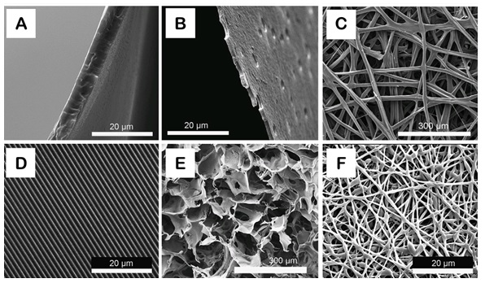
Figure: Templates made from BMSF. A: thin film; B: ultrathin porous film; C: fibrous mat; D: patterned film; E: porous sponge (freeze-drying); F: fibrous meshwork (electrospinning). [Adapted form Harkin et al., 2011].

Selected publications
- Chirila TV, Barnard Z, Zainuddin, Harkin DG, Schwab IR, Hirst LW (2008) Bombyx mori silk fribroin membranes as potential substrata for epithelial constructs used in the management of ocular surface disorders. Tissue Eng. Part A 14:1203-1211.
- Harkin DG, George KA, Madden PW, Schwab IR, Hutmacher DW, Chirila TV (2011) Silk fibroin in ocular tissue reconstruction. Biomaterials 32:2445-2458.
- Madden PW, Lai JNX, George KA, Giovenco T, Harkin DG, Chirila TV (2011) Human corneal endothelial cell growth on a silk fibroin membrane. Biomaterials 32:4076-4084.
- Harkin DG, Chirila TV (2012) Silk fibroin in ocular surface reconstruction: what is its potential as a biomaterial in ophthalmics? Future Med. Chem. 4:2145-2147.
- Bray LJ, Suzuki S, Harkin DG, Chirila TV (2013) Incorporation of exogenous RGD peptide and inter-species blending as strategies for enhancing human corneal epithelial growth on Bombyx mori silk fibroin membranes. J. Funct. Biomater. 4:74-88.
- Chirila TV, Suzuki S, Bray LJ, Barnett NL, Harkin DG (2013) Evaluation of silk sericin as a biomaterial: in vitro growth of human corneal limbal epithelial cells on Bombyx mori sericin membranes. Prog. Biomater. 2(1):14; doi: 10.1186/2194-0517-2-14 (10 pages).
- Chirila TV, Suzuki S, Hirst LW, Harkin DG (2016) Reconstruction of ocular surface using biomaterial templates. In: Biomaterials and Regenerative Medicine in Ophthalmology, 2nd Edn, Chirila TV, Harkin DG (Eds), Elsevier, Amsterdam, pp. 179-218.
- Shadforth AMA, Chirila TV, Harkin DG, Kwan ASL, Chan FK (2016) Biomaterial templates for the culture and transplantation of retinal pigment epithelial cells: a critical review. In: Biomaterials and Regenerative Medicine in Ophthalmology, 2nd Edn, Chirila TV, Harkin DG (Eds), Elsevier, Amsterdam, pp. 263-289.
- Chirila TV, Suzuki S, Papolla C (2017) A comparative investigation of Bombyx mori silk fibroin hydrogels generated by chemical and enzymatic crosslinking. Biotechnol. Appl. Biochem. 64:771-781.
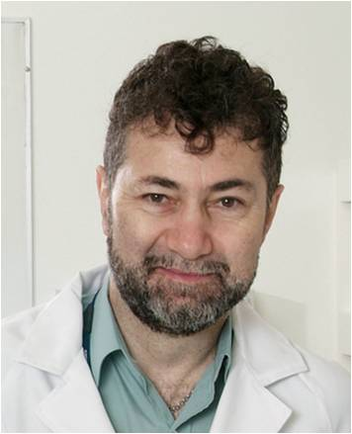

Biography
Traian Chirila is currently the Chief Scientist of Queensland Eye Institute in Brisbane, Australia, and holds professorships at two Australian universities. He has established at Lions Eye Institute in Perth the first laboratory in Australia for research in ophthalmic biomaterials/tissue engineering. Professor Chirila is a recognized expert in polymeric materials and biomaterials. A particularly significant outcome has been the use in clinical practice of the artificial cornea AlphaCor™ and ocular socket implant AlphaShere™, both developed under his guidance. To date, he published 195 papers and book chapters, edited 2 books and 2 special journal issues, and is a named inventor on 13 patents. He was the editor of the first book ever on biomaterials and regenerative medicine in ophthalmology. Professor Chirila is a fellow of the Royal Australian Chemical Institute, a Fellow of the Royal Society of Chemistry, and a member of the American Chemical Society. He is currently a member on twelve journal editorial boards.

