Improving Oral Care Performance for Patients with Oral Cancer Received Micro Reconstruction Surgery
H, -H. Chen ^{1,2}, L. -Y. Chang, ^{1,2}, M. -R. Zeng², *H. -C. Tai ^{1.2}

¹ Chang Gung University of Science and Technology, Puzi City, Chiayi County, Taiwan
²Chiayi Chang Gung Memorial hospital, Puzi City, Chiayi County, Taiwan

Abstract

Objectives: To improve the quality of oral care for the patients with oral cancer after conducted micro reconstruction surgery (MRS) through the design of healthcare training activities for nursing staffs in Taiwan.
Design: An experimental study of single group pre- and post-tests without control group.
Setting: General wards of plastic surgery in a Class I teaching hospital in southern Taiwan.
Participants: 14 nursing staffs and 12 patients were recruited on convenient sampling strategy.
Outcome measures: To investigate the nurses’ cognitive level, an instrument - Cognitive Test of Oral Nursing after MRS, were designed based on the literature (Lee, Y.C., Hsu, Y.C., & Chiang, H.Y. 2017). It contains 10 True/False questions. Another tool - Evaluation Form of Oral Nursing Skills Post MRS - modified from the existing hospital criteria were also utilized. It consists of 15 items of 4 points Likert scale. Collected data were analysed by Repeated Measure MANOVA and T-tests.
Intervention: Development of the Oral Care Nursing Measures (OCNM) for patients experienced MRS. 7 measures include: holding on job training, revising reference manual, setting caring standards, implementing regular audit mechanism, producing posters for healthcare education, updating healthcare education process, and making oral cleaning kits.
Results: Nursing staff's cognitive accuracy improved significantly (t=12.84, p<.001, 2tailed). Oral care clinical skills had significant improvement (F=117.37, p<.001). Positive feedback obtained from the patients.
Conclusions: Implementation of OCNM will help ameliorate the quality of healthcare for patients received MRS.

Keywords - Oral Cancer; Oral Care; Micro Reconstruction Surgery; Oral Care Nursing Measures

Professional Biography
The first author, Ms. Hsing-Hwa Chen, is an undergraduate student studying in the nursing department of Chang Gung University of Science and Technology. She is now working for Chang-Gung Memorial Hospital as a Nurse Practitioner in the Emergency Room. Ms. Chen has been working in the nursing field for over 15 years. She has experience in various departments such as oral cancer ward, intensive care unit, operation room, and so on.
The corresponding author, Dr. Hung-Cheng Tai, is an Associate Professor working for the department of General Education in the same university. He is also a Joint Appointment Research Fellow of Chang Gung Memorial Hospital. Dr. Tai has been teaching English for nursing students at different levels for over fourteen years. He has published a few research articles in the SCI/SSCI journals including Nurse Education Today and BMJ open, etc. in the medical and nursing field.

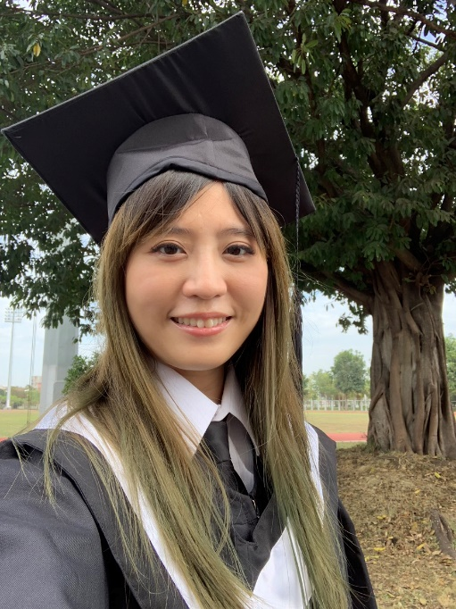
Full Name： Hsing-Hwa Chen
Email Id: benma0710@gmail.com
Contact No: +886-909973710
Social Network Details (FaceBook):

Any Comments:
Lee, Y. C., Hsu, Y. C., & Chiang, H. Y. (2017). Development of the oral assessment scale for post-operational patients with oral cancer. The Journal of Nursing, 64(2), 66–75.

