Keep Calm and Deprescribe: The Art of Deprescribing in the Elderly
Michelle Keating-Sibel MSN, FNP-BC

Keep Calm and Deprescribe: The Art of Deprescribing in the Elderly
As a patient ages, the medications they take can sometimes cause more harm than good – even medications they have tolerated well for many years. As the population ages it is more important than ever to become familiar with the adverse effects associated with commonly prescribed medications. This presentation will serve to educate providers about these commonly prescribed medication, the adverse effects they cause, and how to best manage these conditions when the “offending” medication is removed.
Keywords – Geriatric Medication, adverse effects, deprescribing,

Professional Biography (100-150 words)

Michelle Keating-Sibel has over 15 years experience in management, recruitment and marketing. Michelle started her career in professional recruitment. She coached prospective candidates in the art of interviewing and securing employment in the finance and high tech industries. She moved onto the other side of the recruitment desk when she was hired to recruit and develop sales teams for a Fortune 200 Company. Looking for a more significant sociological impact, in 2008 Michelle started to transition her experience into a career in nursing.
As a nurse practitioner, in addition to actively treating patients ranging from infancy to geriatric care, Michelle has informally found herself recruiting and coaching for her profession. She has precepted a number of nurse practitioner students and identified that there are a number of very important topics not covered in most nurse practitioner programs. As the population is aging, there is no better time than now for nurse practitioners to position themselves in a role as a high quality, cost effective solution to healthcare.
Michelle holds a bachelor of science in biology from East Stroudsburg University, and a BSN and MSN from Villanova University, Villanova, Pennsylvania, US. She is currently enrolled in the Doctor of Nursing Practice at West Chester University with an anticipated date of completion in May 2019.

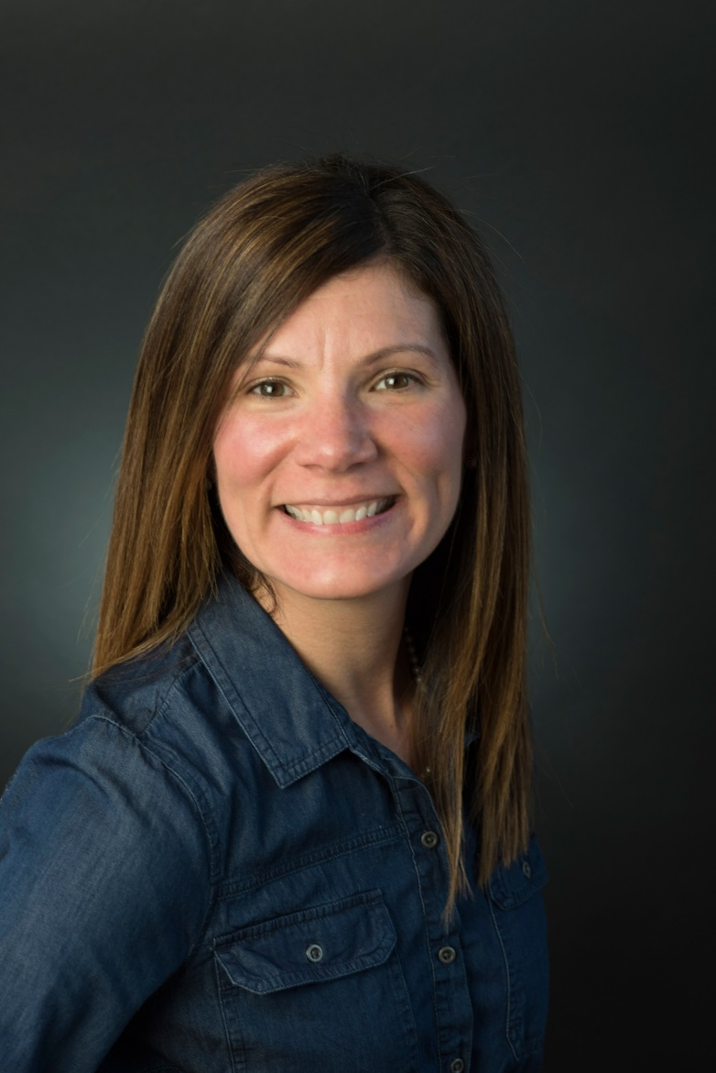

Michelle Keating-Sibel, MSN, FNP-BC
michelleAkeating@hotmail.com
Contact No: 267-371-9425
Social Network Details (FaceBook/LinkedIn): https://www.linkedin.com/in/michelleakeating/

