Title: The impact of a service improvement program in a well-established RIG service
Filipe Carvalho (The Royal Marsden Hospital, London, United Kingdom)

Abstract
The placement of RIGs (Radiologically Inserted Gastrostomies) has been a common practice in the United Kingdom for more than thirty years and used as a strategy for long term feeding requirements. They are a well-established mean of supporting the nutritional requirements of cancer patients who suffer, or are at risk, of dysphagia due to malignancy or cancer treatment. However, they are not without risk.
Following review of the RIG service, which identified major and unnecessary complications, a Lead Nurse for Gastrostomies devices was appointed, with the aim of improving patient experience and reduce complication rates. Subsequently, a service improvement program (SIP), described below, was created and implemented in order to achieve that:
- Update and development of policies and protocols.
- Development and implementation of a Gastrostomy Care bundle pathway.
- Development of knowledge in gastrostomy care amongst nursing staff via formal teaching sessions and by encouraging and motivating attendance.
- Clinical assessment of patient and RIG care teaching, within 24h following insertion, and via telephone clinic at week 1 and week 2.
- Lead Nurse who acts as a senior figure, ensures constant provision of effective, high quality care, and is available for trouble-shooting, support and advice.
Following implementation of the SIP a retrospective observational study over a two year period divided in two time points (Time 1 – previous to SIP, Time 2 – following SIP) was done, showing:
- The overall incidence of complications decreased, and events such as bleeding or tube being inserted incorrectly, which are considered serious and major complications, were not noted in Time 2, contrary to Time 1.
- The overall incidence of complications decreased, specifically late complications, falling from 24% to 15%.
- The percentage of patients without any type of complications up to 30 days post insertion, increased from 74% to 83%.

Professional Biography
Filipe Carvalho is an Advanced Nurse Practitioner in Colorectal Surgery and also the Lead Nurse for Gastrostomies devices, in a specialist cancer treatment hospital in London. He has a Graduate Diploma in Cancer Care and an MSc in Advance Practice in Clinical Cancer Care. Over the last two years he contributed in the development of policies and protocols which have improved the quality of the service and worked alongside the clinical education team in training nursing staff across the Trust, ensuring constant provision of effective, high quality care that is compliant with National/Trust standards.

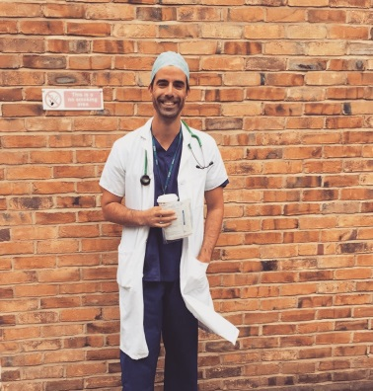

Filipe Luis Susano de Carvalho
4nurse@gmail.com
+44 7549982848
linkedin.com/in/filipe-carvalho-b8602698

