An innovative tool for supporting and measuring recovery in therapeutic communities
Mr Nick Karr, Ms Joy MacKeith and Dr Anna Good (Triangle, UK)

Abstract
Statement of the Problem: Too often organizations supporting those with addiction problems report outputs or activities rather than using measures that provide an in-depth understanding of the journey beneficiaries make. When outcome measures are used, they typically capture practitioner or beneficiary viewpoints but do not combine these perspectives or benefit the therapeutic relationship.

The Drug and Alcohol Star, a version of the Outcomes Star, was developed to address these needs. Completing the Outcomes Star is integral to service delivery and fits well with Motivational interviewing (MI). Both the Star and MI approaches are client centred, strengths based, focus on solutions not problems and engage the individual to uncover where there are in the change process.

The Drug and Alcohol Star involves beneficiaries and practitioners collaborating to agree needs, action plans and progress.

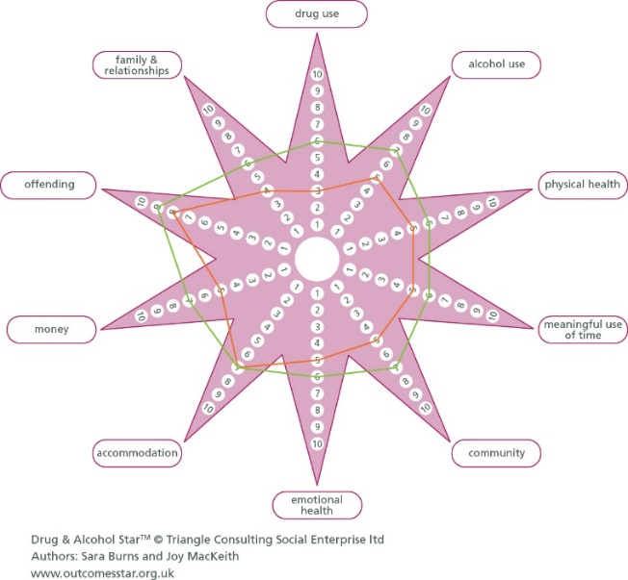

Following calls for a version of the Outcomes Star for gambling addiction, this study identified the outcome areas and ‘Journey of Change’ for a Gambling Star suitable for therapeutic communities and other settings.
Methodology & Theoretical Orientation: Drawing on Participatory Action Research principles, two focus groups were conducted with practitioners and beneficiaries in Australian addiction services. The outcome areas and Journey of Change were identified using an iterative process of drafting and refinement.

Findings: The eight outcomes areas identified as being impacted on by gambling, and the five Journey of Change stages were as follows:
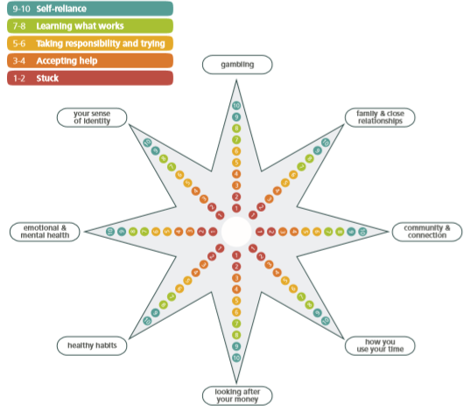

Detailed descriptors for the 10-points of the Journey of Change stages within each outcome area are currently being piloted. Acceptability and validity will be assessed using pilot data.
Conclusion & Significance: The Outcomes Star offers a way to enhance delivery and assessment of addiction services. Therapeutic communities can benefit from using the Drug and Alcohol Star and Gambling Star, empowering beneficiaries, building insight and measuring outcomes in areas impacted by addiction.
Publications
- Good, A, MacKeith (in press) Assessing Family Functioning: Psychometric Evaluation of the Family Star Plus. Family Relations.
- Good, A, Harris, PR, Jessop, D, Abraham, C (2015). Open‐mindedness can decrease persuasion amongst adolescents: The role of self‐affirmation. British Journal of Health Psychology, 20: 228-242.
- MacKeith, J (2014). Assessing the reliability of the Outcomes Star in research and practice. Housing, Care and Support 14:98-106.
- MacKeith, J. (2011). The development of the outcomes star: a participatory approach to assessment and outcome measurement. Housing, Care and Support 14: 98-106.
- Burns, S, MacKeith, J, & Graham, K. (2008). Using the Outcomes Star: Impact and good practice. Triangle, https://www.outcomesstar.org.uk/wp-content/uploads/Q_Outcomes-Star-Impact-and-good-practice.pdf
Biography
Nick Karr has worked with Triangle for nine years and after delivering the first Outcomes Star training in the USA in 2010, he then helped establish and ran the Outcomes Star in Australia for two years. Nick is a London based psychotherapist where he has worked in a range of specialist clinical roles and is now the Lead in an NHS service for people with mental health and substance misuse problems. He completed a Masters’ in Social Work at the Tavistock Clinic, taught on university social work and mental health programs, and is also a Professional Advisor for Young Minds and a Clinical Supervisor for Shout, which is the UK’s 24/7 Crisis Text Line service.
Nick@triangleconsulting.co.uk

Nick@

