Co-creating a new model of care for people in addiction treatment.

Sebastian Ramirez Loaiza, MDes, University of Cincinnati, USA
Dr. Claudia B. Rebola, PhD, University of Cincinnati, USA

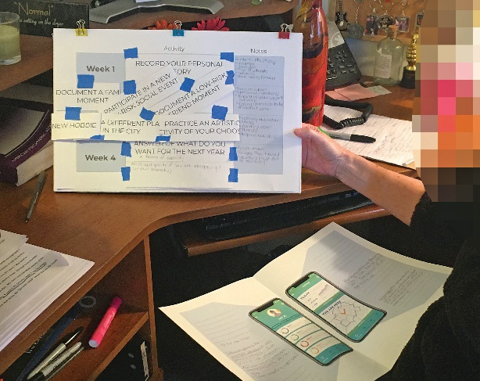

Abstract

A key aspect of addiction treatment is community engagement, but patients have trouble engaging in new relationships and being an active part of the community.

After the AntiOD project and fighting the opioid epidemic through educating people about the crisis, raising awareness and decreasing the stigma, empowering the public to take responsibility and react in the event of an overdose and improving the access to Narcan; we have learned that saving lives requires the involvement of the community.

However, after surviving an overdose, a person is still likely to suffer a subsequent overdose and those who start addiction treatment face high drop out rates.

Two major points in successful treatment cases and lower relapse rates are social engagement and meaningful belonging. But the patients in treatment face difficulties engaging in new relationships, isolation, and difficulty re-engaging as an active part of the community. On the other hand, communities still stigmatize people in addiction treatment, caring of patients is delegated or overlooked and there is a need for education and sensitization in the matter.

There is an opportunity for devising new methods to prevent relapse. A bottom-up approach, similar to AntiOD, where communities assume responsibility on their members in treatment and take action, providing a system of care.

The purpose of this paper is to describe the first stages of an exploratory research, using user-centered design to understand the need for such systems but also to present data from users to advance a new model of care of people in addiction treatment. A community-based initiative that can impact relapse rates.
Image

Recent Publications
- Rebola, C. B., & Ramirez Loaiza, S. (2019). AntiOD: A Smart City Initiative to Fight the Opioid Crisis. In Proceedings of the Future Technologies Conference (pp. 300-305).
- Capraro, G. A., & Rebola, C. B. (2018). The NaloxBox program in Rhode Island: a model for community-access Naloxone.
- DiTirro, T. (2019). AntiOD: Naloxone kits to be available throughout downtown Cincinnati. Local 12 WKRC-TV. https://local12.com/news/local/antiod-naloxone-kits-to-be-available-throughout-downtown-cincinnati
- Hissong, R. (2019). After Dela, AntiOD Device Ready For Deployment. Spectrum News 1. https://spectrumnews1.com/oh/cincinnati/news/2019/11/08/after-delay--antiod-device-ready-for-deployment#
- Kern, J. (2019). UC team uses design to combat opioid crisis. UC News. https://www.uc.edu/news/articles/2019/01/n2061094.html

 Biography
Sebastian Ramirez Loaiza is an Industrial Designer with more than 10 years of industry experience in areas like design management, product design, prototyping, and brand development. as a Master of Design, at the University of Cincinnati, he has focused on social innovation and has been part of different research projects on social topics that include an aging population, opioid crisis, and addiction treatment.
In design-driven research, he has participated and led multidisciplinary teams where he conducts and qualitative methods but also co-creation approaches and human-centered design for a better understanding of the users, research synthesis and innovative solutions.
Email: ramirej3@mail.uc.edu

Notes/Comments:

Related publications are about AntiOD and a previous publication of this paper’s co-author

