Identifying Risky Drug-Seeking Behaviour at the Point-of-Care
Jaya Tripathi, M.S.
The MITRE Corporation, USA

Abstract (300 word limit)
Statement of the Problem: There have been many efforts in the last few years to address the opioid epidemic. Despite the efforts, deaths involving opioid overdoses have continued to rise. One effort has been mandates in 41 states requiring a prescriber to check the state’s PDMP (Prescription Drug Monitoring Program) before prescribing a controlled substance. Prescribers must carefully assess each patient’s risk of medication abuse. This task is challenging, as it can be difficult to distinguish between a person who may be visiting multiple clinicians because of substance abuse disorder and legitimate patients with acute exacerbations of chronic pain. Other challenges faced by physicians include lack of PDMP-EHR integration, and a lack of decision-making tools for pain management. Thus these PDMP datasets remain under-utilized in terms of applying advanced analytic and visualization techniques that would help with decision-making at the point of care.
Methodology & Theoretical Orientation: At the outset of our research, we did a landscape study and assessed that there is considerable subjectivity in pain management approaches; decision-making is limited to physicians’ gestalt, to high-level guidance practices like ‘traffic rules’, to CDC guidelines, etc.
We applied advanced analytic and visualization techniques to a large PDMP dataset of over 12m. records. Using the outcomes from our models, we developed the MeDSS tool. We first conducted a usability study with the Board of Pharmacy and improved our tool based on the feedback. We then did a cross-over study whose purpose was to determine how the MeDSS tool improves efficiency and recognition of high-risk factors and reduces subjectivity in opioid-prescribing decision-making. 50 physicians from Brigham and Women’s Hospital in Boston participated in the study, 25 were shown MeDSS and 25 the standard PDMP view.
Conclusion & Significance: The key findings are that the new tool reduced the subjectivity in decision-making. The test group was able to quickly glean Important information such as payment type, harmful polypharmacy, cross-state activity, etc. We also found a difference in the decision to prescribe an opioid for some of the patient profiles.

Image

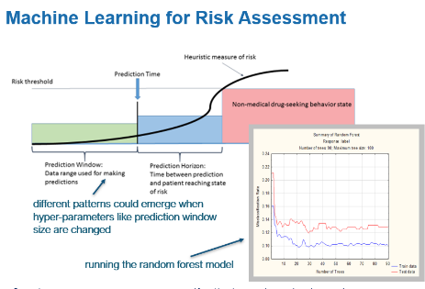

Recent Publications (minimum 5)

- “Advanced Visualizations to Interpret Prescription Drug Monitoring Program Information.” Weiner, S., Sherritt, K., Tseng, Z., Tripathi, J. Accepted in J. Drug and Alcohol Dependence (2019)
- “PDMP 3.0: Investigating the Future of Prescription Drug Monitoring Programs.” Doyle, S., Leichtling, G., Tripathi, J., Weiner, Rx Drug Abuse and Heroin Summit, Atlanta (2019).
- “Improving Provider Risk-assessment Tools to Support Safe and Appropriate Prescribing.” Clark, K., Huizenga, J., Kreiner, P., Tripathi. Duke-Margolis Center for Health Policy, National Press Club, Washington, D.C. (2018)
- Plenary Session: Using Advanced Analytics to Enhance Decision Making.” Cody., S., Goyal, R., Johnson, R., Tripathi, J. Public Health and Safety Symposium, Mathematica Policy Institute, Washington, D.C. The Potential of Wastewater Testing (2017)
- “Predictors of Relapse of Patients in Office-Based Buprenorphine Treatment.” Tripathi, J., Insler, J. AcademyHealth Annual Research Meeting, New Orleans. (2017)
- “Data Analytics Takes the Pain out of Pain Pill Management.” Tripathi, J., Weiner. S. HIMMS (Healthcare Information and Management Systems Society) Annual Conference, Las Vegas. (2016)



Biography (150 word limit)
Jaya Tripathi is a Principal Scientist and Advanced Analytics at MITRE, a federally-funded nonprofit that works in the public interest. Since 2010, her research has focused on various aspects of the opioid epidemic. She is the inventor of various data-driven, actionable tools to assist with opioid management decision-making at the point-of-care, identifying prescriber fraud schemes, geospatial analytics and evaluating a patient’s risk of drug overdose where the prediction horizon can be parametrized. She is currently developing a policy simulator studying MAT-related policies. Ms. Tripathi has presented her research at numerous conferences and has been invited as a subject matter expert on panels at important national venues. She is a peer reviewer for academic conferences and government grants. She has also presented her work to the Surgeon General, the Comptroller General at GAO, the OMB and ONDCP at the White House.

Email: jaya@kolesnik.org

Notes/Comments:

