Accessible and flexible digital addiction
Lars Öhman, Addiction Therapist, RevErea, Sverige

Abstract (300 word limit)

Is it possible to conduct digital processing with simple tools?

RevErea means HONOR in Latin. For us, its means that our work must be characterized by the fact that the name and our business with its content have a good reputation. That we who work have a high sense of duty, are moral, honest and trustworthy towards clients, remitters and collaborative partners.

HEAT in this context also means that we are proud of our work. Proud to work with you.

With a simple search with the words internet-based intervention on Google, it emerges that today, more and more is being researched on internet-based interventions both as self-help but also with the help of professionals. As self-help interventions, today we can see good and positive results, among other things via www.alkoholhjalpen.se and there is also more and more research into the fact that pure treatment via the net has positive effects.

One way to capture the motivation is to use screening tools that show the extent of the problem behavior and the client's ability to change. Such screening tools are currently available to the profession and are made available to the client when the profession meets them. Being able to do the screening tools more accessible via the network could lead to individuals seeing their problems with other eyes and thus either self-healing everything is seeking help to a greater extent.

Today, we will present our approach with three simple tools from investigation to treatment with digital tools which means that we can lower the treatment costs.
Image
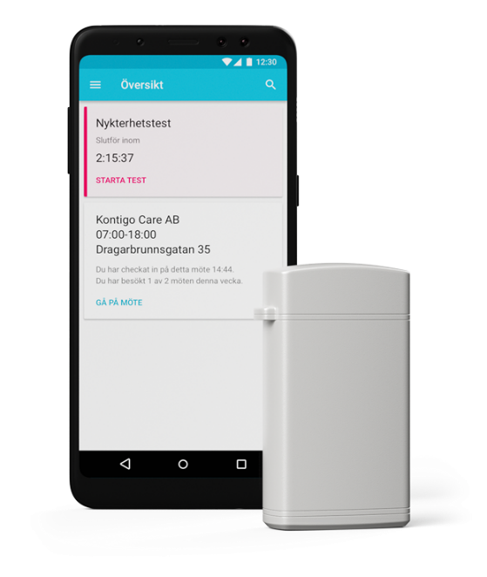
Recent Publications (minimum 5)
- Hämäläinen M, Et al (2018) Real-time Monitoring using a breathalyzer-based eHealth system can identify lapse/relapse patterns in alcohol use disorder Patients. Alcohol and Alcoholism, Volume 53, Issue 4, July 2018, Page 499,
- Jonasson, B., Jonasson, U., Ekselius, L. & von Knorring, L. (1997). The Feasibility of a New Intake Routine to Assess Substance Use Disorders by Means of a Structured Interview. General Hospital Psychiatry. 19, 36-41.

Biography (150 word limit)
Lars Öhman is a dependency therapist who for many years has been working to find simple pathways to care as an employee in municipal outpatient care. Now as a self-employed, Lars is about to develop his own way of working digital with tools that are available without too high costs. Lars has a master's degree in business administration with a focus on quality management but has never regretted his career choice Mulvihill has her expertise in evaluation and passion in improving the health and wellbeing.

Email: lars.ohman@reverea.se

Notes/Comments:

