Abstract Template
Abstract Title: Intervention of Mind-Body Therapy in the Management of Hypertension
Chandra Nanthakumar

¹ Nanthakumar, C. (HELP University, Malaysia)

Abstract (not more than 300 words)

Hypertension, which is a chronic disease, is one of the most vital cardiovascular risk factors worldwide. In Malaysia, the statistics for adults suffering from hypertension are perturbing as one in three Malaysian adults is afflicted with this disease. This makes up for approximately 30 per cent of the country’s population. Evidence shows that mind-body therapies such as anthroposophical medicine, biofeedback, deep breathing exercises, imagery, meditation, relaxation, tai chi, yoga and shiatsu are safe to practice as complementary or alternative medicine for hypertension.
This paper looks at the intervention of yoga as a mind-body therapy in helping adults reduce or manage blood pressure readings. The intervention of yoga based on Patanjali’s classification of classical yoga, encompasses a variety of asanas (postures) in meditative states with a deep focus on breath, pranayama (expansion of life force), prathyhara (withdrawal of senses), dharana (concentration) and dhyana (meditation). The findings of this review reveal that the intervention of yoga, amongst other things, has resulted in a modest but relatively significant reduction in blood pressure readings and better management of the disease.
Nevertheless, it must be noted that some of the findings are limited due to insignificant sample population and heterogeneity. Despite the limitations, yoga appears to be an effective modality in the management and /or reduction in blood pressure. Additional rigorous studies are needed to further investigate the potential benefits of yoga in not only lowering and managing blood pressure, but also in determining the optimal yoga program design for the individual. Yoga is a practice which requires discipline and if one is willing to adhere to it, they may be able to experience the multiple benefits of this ancient therapy.
Keywords—adults, hypertension, meditation, yoga

Professional Biography (100-150 words)

Chandra Nanthakumar, a certified yoga instructor/therapist, received her Classical Yoga training at the Malaysian Association of Yoga Instructors. She specializes in anti-aging and pregnancy yoga, pranayama (expansion of life force) techniques, and dhyana (meditation) techniques). Her doctorate is in the field of Natural Health Sciences specializing in yoga therapy. She has presented papers at international conferences; the most recent one was at the Integrative Medicine Meeting in Germany in 2016 where she presented a paper on the intervention of meditative movement in breast cancer treatment. Her most recent publication is on the benefits of yoga in children; the article was published in the Journal of Integrative Medicine in January 2018. Being an advocate of natural healing methodology, she conducts Hatha Yoga classes and workshops regularly to help the community cope with various ailments. She strongly believes that if one practices yoga earnestly, they will be able to keep the doctor at bay.

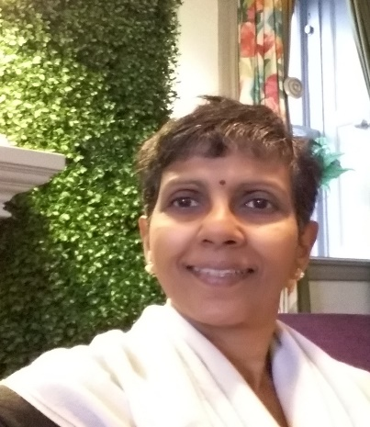

Email id: chandratk@help.edu.my

