Title: Concussions and Traumatic Brain Injury – Implications of Trauma
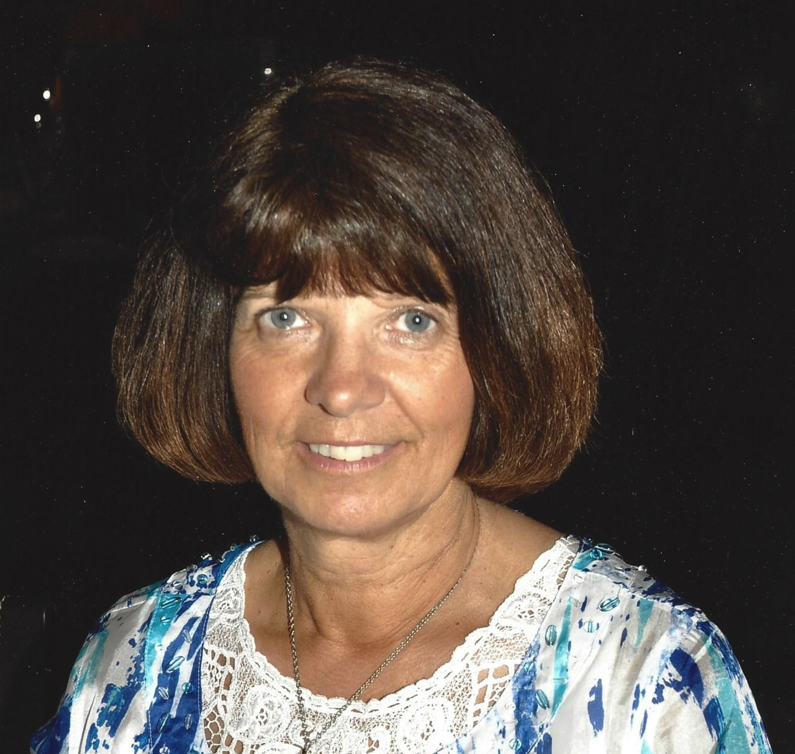
and Resolution

This workshop will provide individuals with tools for assessment of concussions
and traumatic brain injuries as well as an understanding at a physiological level
of what occurs with the glymphatic flow, the astrocytes, and the aquaporins of
the brain during trauma.

There are many factors which reduce brain resilience even before a trauma occurs including nutritional deficiencies as simple as magnesium which can lower seizure thresholds; electromagnetic frequencies which impair melatonin production; and herbicide/pesticide exposure which disrupts the gut microbiome and alters neurotransmitter production. Understanding how these impair the biochemical pathways enables us to make choices for optimal outcomes in those with concussions and traumatic brain injuries as well as reduces their risk developing long-term neurological diseases such as Alzheimer’s.

From assessment, to cellular repair using homeopathy, botanical, and nutritional supplements, and ultimately QEEG and neurofeedback training, we have designed a duplicatable template for optimal healing.

Biography
Dr. Paula Rochelle completed her Doctor of Naturopathy from Trinity School of Natural Health in 1999. She is board certified in Traditional Naturopathy by the American Naturopathic Medical Association. Dr. Rochelle completed her board certification in Naturopathic Endocrinology in 2002. She spent 3 years on contract to NeuroScience Laboratories as a part of team researching neurotransmitters. She is the director of 2 multidisciplinary alternative medicine clinics. In 2006, Dr. Rochelle crashed an airplane and as a result focuses her work on assessing, and correcting brain trauma. She is the formulator of ASuRA brain – a product designed to open up the aquaporins in the brain enabling the brain to detoxify.

Paula L Rochelle
1-918-645-4004
www.aysanahealth.com
Category: Workshop

