Ivacaftor Nanoemulsion: Characterization and In-vitro studies
Dr Bhupendra G. Prajapati, PhD, Ganpat University, India
Mr. Akshay Parihar, M.Pharm, Ganpat University, India

Abstract (300 word limit)
Biocompatible lipid matrices are used for the solubility enhancement of nanotherapeutics which are poorly water soluble. Nanoemulsions helps in improving the drug stability its bioavailability. Targeted delivery of therapeutics can be achieved with this type of formulation approach. The current research work is focused on increasing the solubility of BCS class II drug, which is having very low solubility and variable bioavailability with different individuals. Solubility of the drug in lipid, surfactant and cosurfactant was identified with the help of solubility studies and it was found that Transcutol-p showed significant solubility to be used as co-surfactant. Tween 20 was selected as lipid while Capmul was selected as surfactant because they were able to exhibit highest drug solubility among the screened surfactants, co-surfactants, and oils. Nanoemulsion of drug was formulated with the help of high-speed homogenization technique. The observed Zeta potential was -15.75mv. The In-vitro studies showed that NE1 was able to exhibit 97.55% drug release in a span of 45 minutes. We were able to increase the solubility of Ivacaftor effectively..

Image

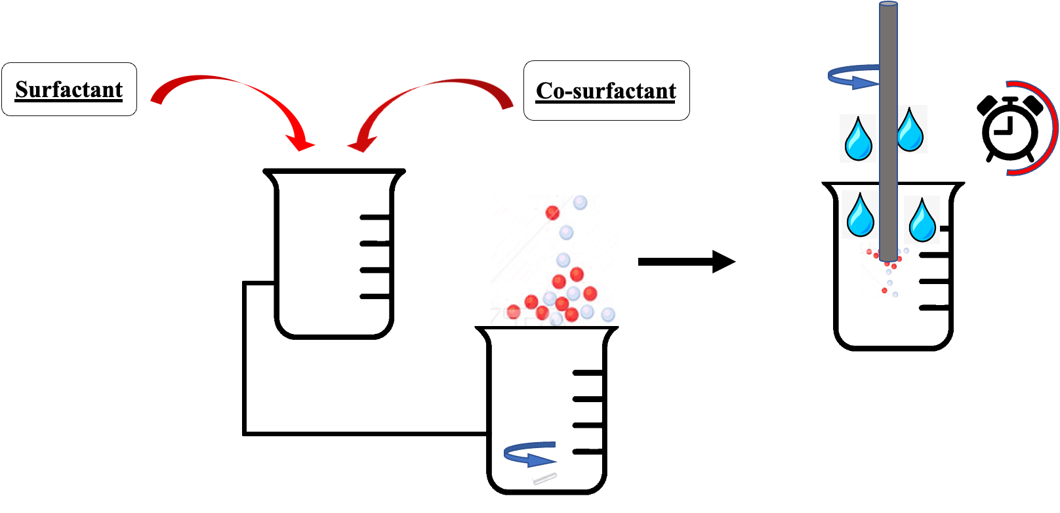
Recent Publications (minimum 5)
1. Bhattacharya, S., Saindane, D., & Prajapati, B. G. (2022). Liposomal Drug Delivery and Its Potential Impact On Cancer Research. Anti-cancer agents in medicinal chemistry, 10.2174/1871520622666220418141640. Advance online publication.
2. Paliwal, H., Parihar, A., & Prajapati, B. G. (2022). Current State-of-the-Art and New Trends in Self-Assembled Nanocarriers as Drug Delivery Systems. Front. Nanotechnol. 4: 836674. doi: 10.3389/fnano.
3. Prajapati, B., Paliwal, H., & Patel, J. (2022). Pharmacokinetics of Nanoparticle Systems for Pulmonary Delivery. In Pharmacokinetics and Pharmacodynamics of Nanoparticulate Drug Delivery Systems (pp. 347-364). Springer, Cham.
4. Prajapati, B. G., Patel, H. P., & Patel, J. K. (2022). Nanoparticle Pharmacokinetic Profiling In Vivo Using Magnetic Resonance Imaging. In Pharmacokinetics and Pharmacodynamics of Nanoparticulate Drug Delivery Systems (pp. 399-416). Springer, Cham.
5. Prajapati, B. G., Jivani, M., & Paliwal, H. (2021). Formulation and optimization of topical nanoemulsion based gel of mometasone furoate using 32 full factorial design. Indian drugs, 58(06), 19.

Figure 1: Method of Preparation

 Biography
Dr. Bhupendra Prajapati is a Professor in Department of Pharmaceutics, Shree S.K.Patel College of Pharmaceutical Education and Research, Ganpat University, Gujarat, India. He has more than 20 years of academic and research experience, has published more than 100 research and review papers in international and national Journals. Under his editorial two book under process and he authored 20 book chapters in the field of novel drug delivery. He published two Indian patent and three applications under evaluation. He is a reviewer in three high impact journals and is on the editorial board of several scientific journals.
Email: bhupen27@gmail.com

