Silver nanoparticle biogenesis using the fungi penicillium diversum for biological applications
Dr Sharanabasava V. Ganachari PhD, School of Advanced Sciences, KLE Technological University, Hubballi, India,

Abstract

In this present investigation, we report a simple, cost-effective, and eco-friendly method of synthesizing colloidal silver nanoparticles by using fungi Penicillium diversum. UV-visible spectroscopy studies were carried out to quantify the formation of silver nanoparticles. The X-ray diffraction pattern suggests the crystallinity of silver nanoparticles. Atomic force microscopy and transmission electron microscopy images show that the silver nanoparticles are polydispersed and are in a size range of 5 to 45 nm with an average size of 20 nm. From the Fourier transform infrared spectroscopy, we presume that the reductase enzyme present in the fungal extract may be responsible for the reduction and stabilization of the silver nanoparticles. The resultant silver nanoparticles showed effective antimicrobial activity against Escherichia coli, Salmonella typhi, Vibrio cholerae, and the clinical isolate of Paratyphia.

Image
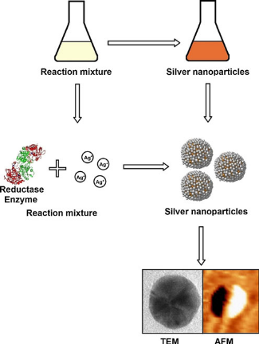
Recent Publications (minimum 5)
- Gajbhiye, M., Kesharwani, J., et al. (2009). Fungus-mediated synthesis of silver nanoparticles and their activity against pathogenic fungi in combination with fluconazole. Nanomedicine: Nanotechnology, Biology, and Medicine, 5, 382–386.
- Ahmad, A., Mukherjee, P., et al. (2003). Extracellular biosynthesis of silver nanoparticles using the fungus Fusarium oxysporum. Colloids and Surfaces. B, Biointerfaces, 28, 313–318.
- Bigall, N. C., & Eychmüller, A. (2010). Synthesis of noble metal nanoparticles and their non-ordered superstructures. Philosophical Transactions of the Royal Society, 368(1915), 1385–1404.

Photograph

Biography
Dr. Sharanabasava V. Ganachari received M.Sc. (2008) and Ph.D. (2013) degrees from the Gulbarga University Kalaburagi. He has been working as a Research Scientist and Assistant Professor at the KLE Technological University, Hubballi, Karnataka, India, since November 2014. He has more than 60 publications, including journal articles, conference articles, book chapters and is the inventor of several patents. Serves as an editorial board member and a reviewer for several prestigious journals.
Email: sharanu14@gmail.com

Notes/Comments:

