Lead-free functional ceramics for dielectric energy storage capacitors
Dr. Zhilun Lu,
Edinburgh Napier University,
United Kingdom

Abstract (300 word limit)

The global popularity of portable electronics and electric vehicles has spurred the development of energy storage devices toward higher power densities and energy densities. Dielectric capacitor, as a kind of important energy storage devices, has attracted tremendous attentions based on the advantages of high power density and fast charge-discharge rate, thus has a critical role to play in decarbonizing the 21st century economy. Finding less toxic, lead-free materials has been a major scientific and technological challenge.

Relaxor ferroelectric and antiferroelectric lead-free ceramics are promising candidates due to their relatively small remanent polarizations and high dielectric breakdown strengths. Novel tailored dopant strategies in BiFeO₃-SrTiO₃ (BF-ST) relaxor ferroelectrics have been proposed in our work: i) Nb-doping to increase resistivity by eliminating hole conduction and promoting electrical homogeneity and ii) alloying with a third perovskite endmember, BiMg_{2/3}Nb_{1/3}O₃ (BMN), to reduce polar coupling without decreasing the average ionic polarizability. Using these strategies, ultrahigh energy density of 15.8 J cm⁻³ for BF-ST has been attained in multilayer ceramics. In addition, we combined theoretical calculations, in-situ synchrotron X-Ray diffraction and transmission electron microscopy data to give evidence to the underlying mechanisms that underpin optimization of energy storage density (6.5 J cm⁻³) in AgNbO₃-based antiferroelectric ceramics from micro to macro scales. It is the first observation of a field induced ferrielectric phase and the first time to propose 4 principles for the design of high energy density in antiferroelectric ceramics. These two works both define clear engineering guidelines to design lead-free ceramics for high energy density capacitors to support sustainable development.
Image
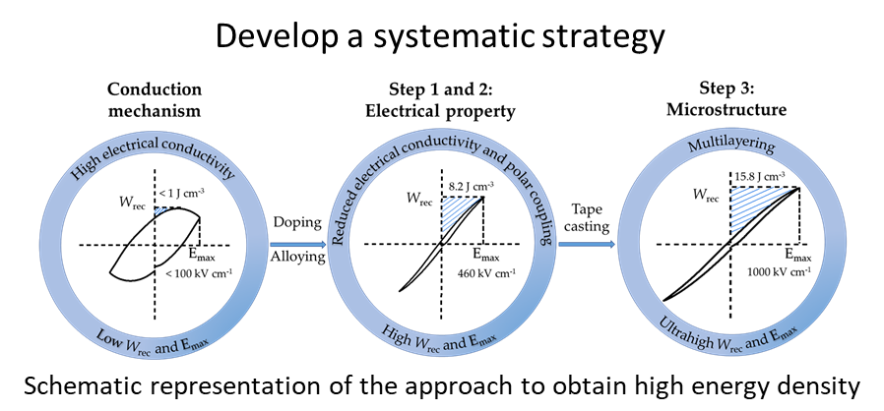
Recent Publications (minimum 5)
- G. Wang, Z. Lu, Y. Li, L. Li, H. Ji, A. Feteira, D. Zhou, D. Wang, S. Zhang and I. M Reaney, Electroceramics for high-energy density capacitors: current status and future perspectives. Chemical Reviews, 121, 6124 (2021).
- Z. Lu, G. Wang, L. Li, Y. Huang, A. Feteira, W. Bao, A. K. Kleppe, F. Xu, D. Wang and I. M. Reaney, In situ poling X-ray diffraction studies of lead-free BiFeO3-SrTiO3 ceramics. Materials Today Physics, 19, 100426 (2021).
- Z. Lu, W. Bao, G. Wang, S. Sun, L. Li, J. Li, H. Yang, H. Ji, A. Feteira, D. Li, F. Xu, A. K. Kleppe, D. Wang, S. Liu and Ian M. Reaney, Mechanism of enhanced energy storage density in AgNbO3-based lead-free antiferroelectrics. Nano Energy, 79, 105423 (2021).
- Z. Lu, G. Wang, W. Bao, J. Li, L. Li, A. Mostaed, H. Yang, H. Ji, D. Li, A. Feteira, F. Xu, D. C. Sinclair, D. Wang, S. Liu and I. M. Reaney, Superior energy density through tailored dopant strategies in multilayer ceramic capacitors. Energy & Environmental Science, 8, 2923 (2020).
- Z. Lu, H. Zhang, W. Lei, D. C. Sinclair and I. M. Reaney, High figure of merit thermoelectric La-doped A-site deficient SrTiO3 ceramics. Chemistry of Materials, 28, 925 (2016).

Photograph

Biography (150 word limit)
Dr Zhilun Lu is a Lecturer (Assistant Professor) in the School of Engineering and the Built Environment at Edinburgh Napier University. He obtained his PhD from the University of Sheffield with the High-Quality PhD Thesis Prize and held post-doctoral research appointments at the Helmholtz-Zentrum Berlin and the Henry Royce Institute.
Dr Lu was awarded research grants by the Royal Society and the Royal Society of Chemistry shortly after joining Edinburgh Napier University. He has published 50+ journal papers (H index=21). One of his papers was selected as a Hot Article (as one of the top 10% of papers) in Energy & Environmental Science in 2020. And another paper was selected as a Highly Cited Article by Web of Science in 2021. He is a Professional Member (MIMMM) of the IOM3, a Member (MRSC) of the Royal Society of Chemistry and a Member of the American Chemical Society. He serves on the editorial boards of 5 prestigious materials journals. He is also a peer reviewer for numerous high-impact journals in physics, chemistry, and materials science including Physical Review Letters, Chemistry of Materials, and Acta Materialia. He has delivered several keynote lectures at international conferences.
Dr Lu’s research focuses on fabrication, characterization and applications of a wide range of advanced functional materials such as dielectric materials for energy storage capacitors, thermoelectric oxides, magnetic materials, microwave ceramics, and high entropy oxides.
Email: Z.Lu@Napier.ac.uk

Notes/Comments:

