Removal of toxic metal ions by synthesized nanomaterials based on manganese MnO₂-Nanosheets
A. AMARRAY,ª S. EL GHACHTOULI,ª M. AZZIª
ª Laboratoire Interface Matériaux-Environnement, Université Hassan II de Casablanca, Faculté des Sciences Ain chock, Maroc.
*aminaamarray93@gmail.com

Abstract
Various treatment technologies employed for the removal of heavy metals include chemical precipitation, ion exchange, chemical oxidation, reduction, reverse osmosis, ultrafiltration and electrodialysis. The adsorption method has proven the most effective because of its simplicity, ease of operation, and high efficiency over a wide range of concentrations. Typical adsorbents for heavy metals include perlite, hydroxyapatites, peat, carbon nanotubes, activated carbon, alumina, and clay. However, these adsorbents have several disadvantages, such as low adsorption capacity, low selectivity, and a long time equilibrium. In this study, we investigated the adsorption behavior of Pb(II) and Cd(II) by MnO₂ nanosheets (MnO₂-NS) in an aqueous medium. The synthesis of (MnO₂-NS) is based on the exfoliation of an intermediate material lamellar leading to the formation of the nanosheets-MnO₂ material with negative charges on its outer surface, which causes a strong attraction of positively charged pollutants like metal cations.² The nanomaterial has been characterized by different spectroscopic techniques (XRD, SEM….etc). The study of interaction in an aqueous medium between the MnO₂ nanosheets and the metal cations Pb(II) and Cd(II) showed that the materials are highly reactive towards the metal cations.
.

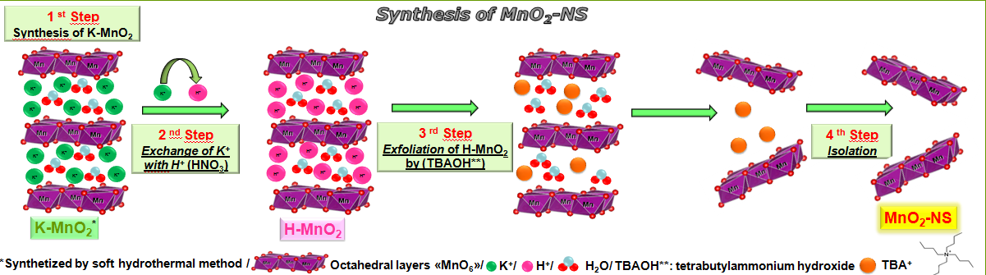
Fig. synthesized nanomaterial based on manganese MnO₂-Nanosheets
References :

1) 1) G. Tan, Y. Liu, and D. Xiao. J. Carbohydr. Polym. 2019, 219, 306–315.
2) L. Peng et al. J. Colloid interface Sci. 2015, 456, 108–115.


Biography
AMARRAY AMINA is a Ph.D. student in chemistry and valorization at Hassan II University since 2017 at the Materials Environment Interface Laboratory, under the direction of Mrs. S. ELGHACHTOULI and Mr. M. AZZI. She is working on the development and characterization of nanomaterials by chemical and electrochemical routes for the removal of organic and inorganic impurities from water.
Email: aminaamarray93@gmail.com

