Post PCI Care in the COVID-19 Era – Delivery Challenges and Health Outcomes
Lina Du, University of California Davis School of Medicine, USA
Dr. Surabhi M. Atreja, University of California Davis Hospital, Department of Cardiology, USA

Abstract (300 word limit)
Statement of the Problem: In this study, we aim to investigate the impact of COVID-19 on the delivery of timely healthcare services for patients who underwent percutaneous coronary intervention (PCI), the primary treatment for myocardial infarction. With COVID-19 putting a significant strain on the healthcare system, access to necessary medical care has been compromised, potentially leading to adverse outcomes such as repeated revascularization and death. By analyzing these effects, we hope to gain valuable insights into how the pandemic has affected patient outcomes and identify potential strategies to mitigate these impacts. Methodology & Theoretical Orientation: We conducted a retrospective cohort study on patients who received PCI treatment and followed up at UC Davis Hospital between April and August in 2019 and 2020. We employed several statistical tests, including Wilcoxon rank sum, Fisher's exact test, Kaplan-Meier curves, and cox proportional hazards models. Conclusion & Significance: Compared to pre-COVID-19 times, there is a significantly longer wait time for enrollment in Cardiac Rehabilitation Program (CRP), and significantly lower enrollment in CRP during COVID-19. Patients receiving PCI during COVID have increased revascularization and death rates, but it was not statistically significant. Our study highlights the significant risk of adverse events for patients undergoing PCI post-treatment and the challenges of limited access to critical cardiac rehabilitation services during this period. The findings have led to a $80K grant to establish a digital monitoring program for post-PCI patients, aimed at reducing the rates of repeated revascularization and death. The program utilizes timely monitoring of blood pressure and physical activity, along with a text messaging communication system, to bridge the gap in accessing in-person cardiac rehabilitation services and inform the development of a virtual cardiac rehabilitation program.
Image
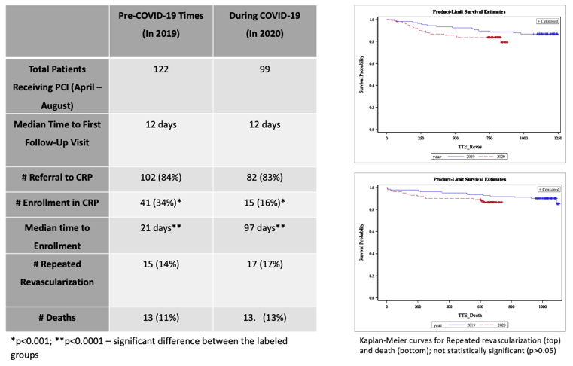

Photograph

Biography
Lina is a rising third-year medical student with a strong interest in cardiology and a passion for improving patient health outcomes through quality improvement research. As the Co-Director of the Paul Hom Student Run Clinic and the lead of the cardiology committee, she conducted quality improvement research to reduce patient wait times and gain insights into the cardiology needs of the patient population. She also collaborated with faculty members on various cardiology-related quality improvement projects. Through her efforts, the team secured a $80K grant to establish a digital monitoring program for post-PCI patients at the hospital. She is currently working closely with technical teams and her mentor to bring this program to fruition and make an impact on post-PCI patient care.
Email: lyidu@ucdavis.edu

Notes/Comments:

