Hedychium spicatum: A comprehensive insight into its ethnobotany, phytochemistry, and pharmacological and therapeutic attributes
Ms. Monika P Singh, Shoolini University, Solan, India
Abstract
The function of medicinal plants in the healthcare system is immense as they are the main source of contemporary medications. Among them Hedychium spicatum is a significant medicinal herb of the family Zingiberaceae (family) that is found mostly in the Himalayan regions. The rhizomes of this plant are the main source of commercial value. This is due to its amazing ability to treat various diseases and ailments. For centuries, Ayurvedic practitioners have turned to rhizomatous plants for relief from symptoms like pain, diarrhea, nausea, liver problems, vomiting, inflammation, headache, stomachache, fever, and more. The major compounds of essential oils are camphene, 1,8-cineole, myrcene, sabinene, α-pinene, and α, β-phellandrene are the plant's primary phytochemical components, making it an important plant for healing. Among its many potential medical uses, it has been studied for its anti-microbial, sedative, anti-inflammatory, antipyretic, hepatoprotective, anti-helminthic, anti-diabetic, and pediculicidal properties. This review intends to provide information on the phytochemistry and medical applications of Hedychium spicatum, a plant with huge uses in traditional medicine and Ayurveda.
Recent Publication:
- Singh M., Book Chapter on Metallic Nanoparticles as Antibacterial Agents Accepted ( Scopus Indexed).
- Singh M., A review on Orchid Plants as Anticancer communicated in Journal of South African Journal of Botany IF 3.11
- Singh M.,Book Chapter on Biological activities of Rumex nepalensis and Hedychium spicatum.
- Singh M., A review on Hedychium spicatum: A comprehensive insight into its ethnopharmacology, phytochemistry, and pharmacological and therapeutic attributes, communicated.
- Singh M., A review on Phytochemistry and Therapeutic Utility of Rumex Nepalensis: A Perennial Herb of Medicinal Importance, to be communicated in next week.
- Singh M., A review on Flavanoids, its synthetic approaches and therapeutic applications: An overview communicated in Current Medicinal Chemistry.

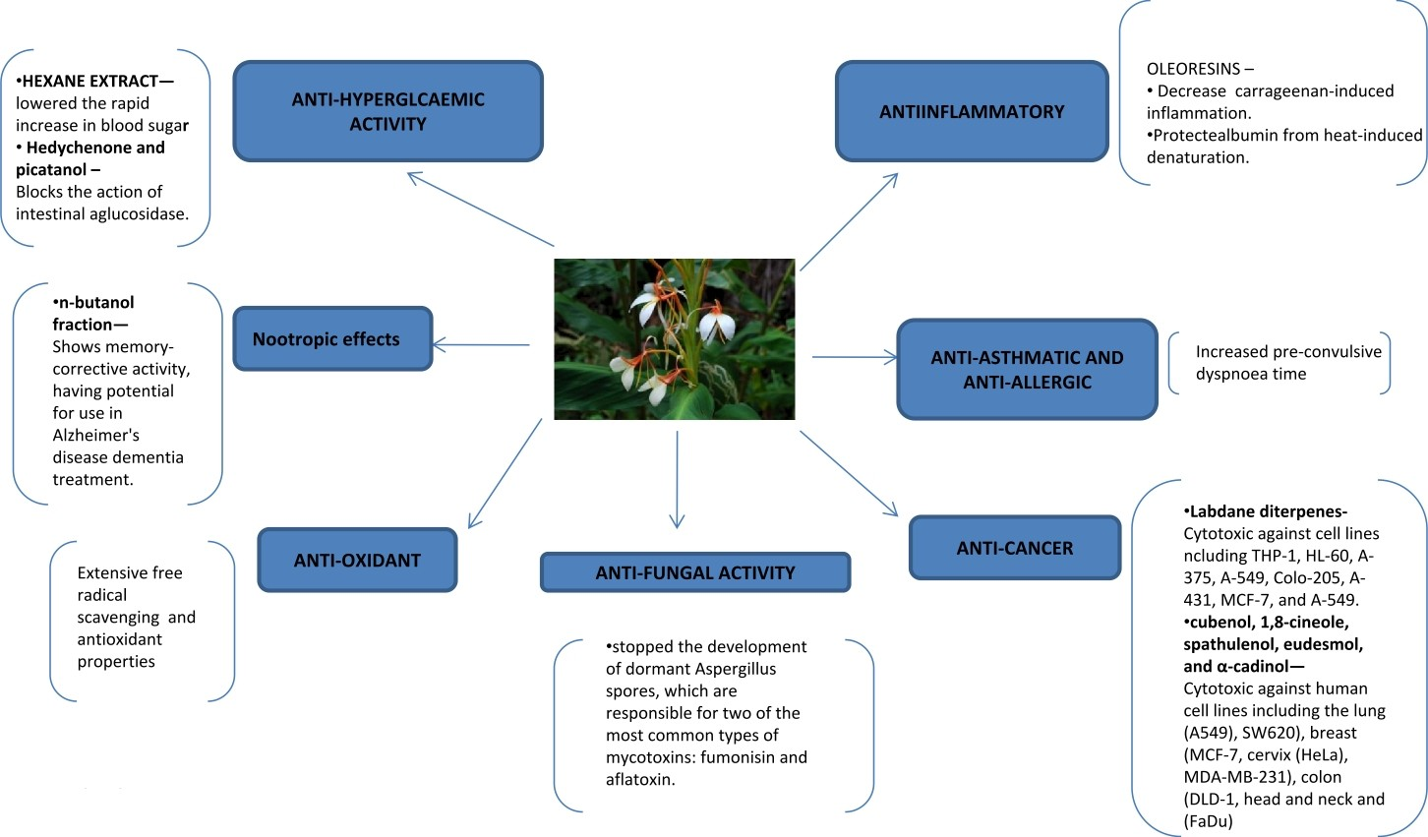

Figure: Pharmacological activities of Hydechium spicatum


Biography:
Ms. Monika Singh has her expertise in extraction, isolation, standardization of herbal plants and plant products as per WHO guidelines and preparation of herbal formulations and standardization. Her research is based on plants for the creation of new ways to improve health care of general people. She has done her MS Pharm from National Institute of Pharmaceutical Sciences and Research Under Dr. SM Jachak with project Title: Preparation, Standardization and Monograph development of Shukramatrika vati: A tablet formulation. She has also helped her student during their project work and always remain enthusiastic about learning new things.

Email: monikasagar999@gmail.com, monikasingh@shooliniuniversity.com

