3D Printing and Circular Economy:
re-manufacturing of fiber glass composites
A. Mantelli, E. Paracchini, M. Levi

Department of Chemistry, Materials and Chemical Engineering “Giulio Natta”
Politecnico di Milano, IT

Abstract

The use of 3D printing for real life objects is often limited to the low amount of materials that can be used or, in some cases, for the cost of the technology. Since the advent of Makers, 3D printing processes started to be cheaper and enthusiasts and researchers began to experiment with them. In the last years the experimentation process has found a prolific terrain fed by low cost materials and machinery, and by a vibrant community. This helps the experimentation on different materials, like ceramics and thermosetting polymers. The possibility to 3D print thermosets materials enabled a whole class of materials to candidate as 3D printable.
A flexible 3D printing process for viscous materials have been developed, such process could be used to 3D print thermoset resin reinforced composite materials. It has been demonstrated that recycled composite material can be 3D printed enabling the recycled material re-manufacturing, following a circular economy approach.
Since the first windfarms constructed in the world are turning 25 years old, and will soon be decommissioned, the aim of this research is to build a circular economy path for thermoset recycled fiberglass reinforced materials in which the 3D printing process creates the added value for a new class of re-manufactured composites and products.
In order to 3D print the material, the viscosity of the system has been analyzed and the polymerization process has been studied and optimized.
A frugal innovation approach have been used: low cost 3D printers could be easily modified to 3D print the new composites, and, thanks to the simplicity of the system, the process could be scaled up, allowing for bigger volume 3D print. Some proposals regarding the possibility of using this novel approach for the construction of attractions within amusement parks have been studied and prototyped.
This research is part of FiberEUse European project.
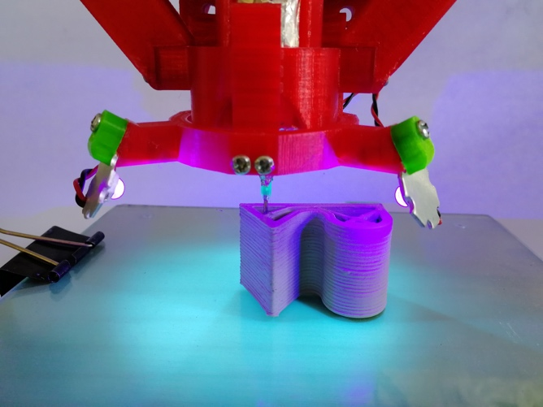
Fig. 1 – Modified 3D printer during the 3D printing of a sample with thermoset resin recycled fiberglass composite.

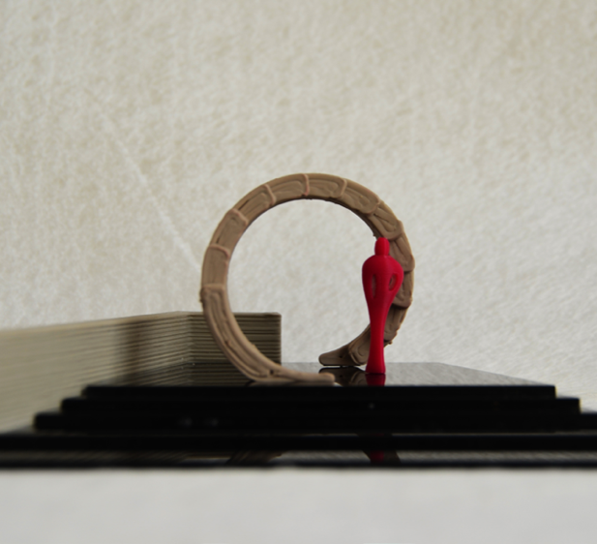
Fig. 2 – 3D printed model of an amusement park gate.

Keywords—3D printing, circular economy, composite material, frugal innovation.

Professional Biography

Andrea Mantelli has completed his Master of Science in Materials Engineering and Nanotechnology at the age of 25 years from Politecnico di Milano with an original work on continuous composite 3D printing. He is working as a research fellow at +Lab in the department of Chemistry, Materials and Chemical Engineering “Giulio Natta” at Politecnico di Milano. He also worked for an internship in 2015 at FabLab London where he consolidated his ‘maker’ attitude.



Email Id: andrea.mantelli@polimi.it

