Cardiac magnetic resonance imaging before and after therapeutic interventions for systemic sclerosis-associated myocarditis.

Stylianos Panopoulos¹, Sophie Mavrogeni², Charalambos Vlachopoulos³, Petros P. Sfikakis¹

¹First Department of Propaedeutic and Internal Medicine and Joint Academic Rheumatology Program, National and Kapodistrian University of Athens, Medical School, Athens, Greece, ²Department of Cardiology, Onassis Cardiac Surgery Center, Athens, Greece, ³First Cardiology Department, Hippokration General Hospital, National and Kapodistrian University of Athens, Medical School, Athens, Greece.

Abstract

Statement of the problem. Primary heart involvement in Systemic sclerosis (SSc), including myocarditis or conduction system disorders, has an estimated prevalence between 7 and 50% and is reported to be the second most frequent SSc-related mortality cause. Early detection and prompt management of cardiac involvement in SSc are of paramount importance. Cardiac Magnetic Resonance (CMR) is increasingly used to evaluate SSc-associated cardiac complications. The purpose of this study is to assess changes, including inflammatory and/or fibrotic myocardial lesions detected by CMR, following therapeutic interventions for SSc-associated symptomatic myocarditis. Methodology and theoretical orientation. In this retrospective study, myocarditis was diagnosed by CMR (2018 revised Lake Louise criteria) in 18 patients (14 diffuse/4 limited SSc, 16/18 women, aged 56±11 years, disease duration 8±11 years, 17/18 with lung involvement) with cardiac symptoms and abnormal echocardiography (4/18) and/or 24-hour Holter monitoring (12/14). CMR was repeated after 8±3 months following administration of cyclophosphamide (n=11, combined with corticosteroids in 3 and rituximab in 1), mycophenolate (n=1), tocilizumab (n=1), methotrexate/corticosteroids (n=2), corticosteroids (n=1) or autologous stem cell transplantation (n=2). Findings. Functional cardiac improvement was evident by increases in left (by 5.8%±7.8%, p=0.006) and right ventricular ejection fraction (by 4.5%±11.4%, p=0.085) in the second CMR compared to the first. Notably, Late Gadolinium Enhancement, currently considered to denote replacement fibrosis, decreased by 3.1%±3.8% (p=0.003), resolving in 6 patients. Markers of myocardial edema, namely T2-ratio and T2-mapping, decreased by 0.27±0.40 (p=0.013) and 6.0±7 (p=0.025), respectively. Conversely, T1-mapping, considered to reflect acute edema and diffuse fibrosis, and extracellular volume fraction, reflecting diffuse fibrosis, remained unchanged. Conclusion and significance. CMR may distinguish between reversible inflammatory/fibrotic and irreversible fibrotic lesions in SSc patients with active myocarditis, confirming the unique nature of primary cardiac involvement in SSc. Whether, and how, CMR should be used to monitor treatment effects in SSc-associated myocarditis warrants further study.
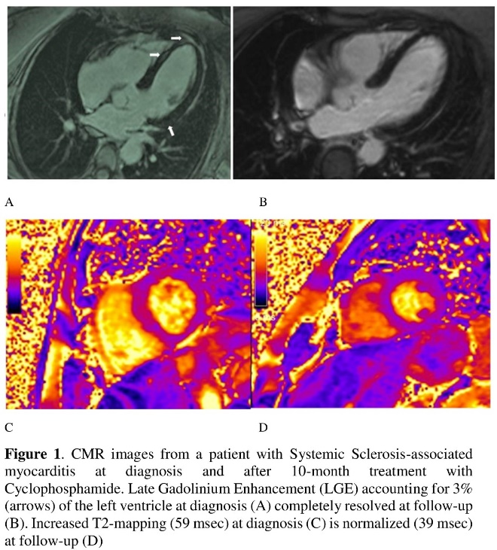
Recent Publications
- Bournia VK, Protogerou AD, Panopoulos S, et al (2008) Update on assessment and management of primary cardiac involvement in systemic sclerosis. J Scleroderma Relat Disord 3:53–65.
- De Luca G, Bombace S, Monti L (2022) Heart Involvement in Systemic Sclerosis: The Role of Magnetic Resonance Imaging. Clin Rev Allergy Immunol doi: 10.1007/s12016-022-08923-3.
- De Luca G, Palmisano A, Campochiaro C, et al (2022) Cardiac magnetic resonance in Systemic Sclerosis myocarditis: the value of T2 mapping to detect myocardial inflammation Rheumatology. doi:10.1093/rheumatology/keac098
- Yu J, Guensch DP, Fischer K, Nadeshalingam G, et al (2014) Performance of T1 mapping vs. T2 mapping for assessing myocardial edema. J Cardiovasc Magn Reson 16:1–2.5.
- Pieroni M, De Santis M, Zizzo G, et al (2014) Recognizing and treating myocarditis in recent-onset systemic sclerosis heart disease: potential utility of immunosuppressive therapy in cardiac damage progression. Semin Arthritis Rheum 43:526–35.

 Dr Panopoulos is a Rheumatologist in General Hospital of Athens ΄΄LAIKO΄΄. He has studied thoroughly the pathogenesis and clinical course of Systemic Sclerosis and has published several original articles regarding the efficacy of different therapeutic regimens for the management of the major clinical manifestations of Systemic Sclerosis as the interstitial lung fibrosis, the heart involvement or the esophageal involvement.
Email: sty.panopoulos@gmail.com

