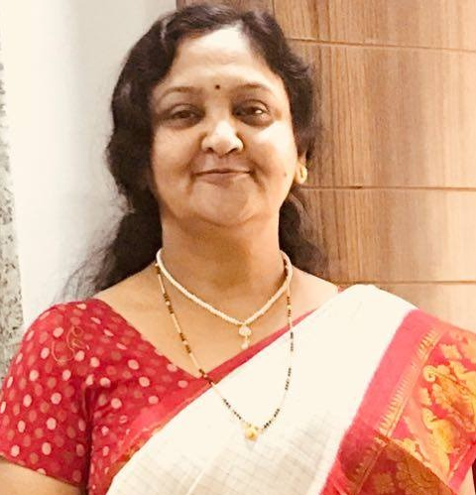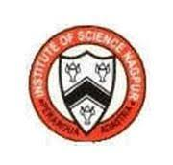
Dr Surekha Anil Kalkar

Photograph

Title: PLANTS AS BIOREACTORS FOR THE SYNTHESIS OF METAL NANOPARTICLE
Name: Dr. Surekha A Kalkar
Associate Professor, Institute of Science, Nagpur, Maharashtra, India.
Email- surekhakalkar@gmail.com
Abstract
While metal nanoparticles are being increasingly used in many sectors of the economy, there is growing interest in the biological and environmental safety of their production. For the syntheses of nanoparticles employing plants can be advantageous over other biological entities which can overcome the time consuming process of employing microbes and maintaining their culture which can lose their potential towards synthesis of nanoparticles. Hence in this regard; use of plant extract for synthesis can form an immense impact in coming decades. Nanoparticles produced by green synthesis methods display synergetic properties where both the nanoparticles as well as the natural active molecule of the plant, influence the biocidal properties. Active efforts to control the size and the shape of the nanoparticles are being carried out and new synthesis procedure are regularly being developed. Plant-extract-based-synthesis-routes represent an eco-friendly alternative showing promise in bio-medical applications and in resolving to some extent the negative effects of synthetic drugs. This paper summarizes the various green approaches for synthesis of MNPs using biopolymers, and plant extracts which qualify as a green chemistry concept and also retain their biological properties.
Keywords: nanoparticles, biopolymers, green synthesis methods.
Biography
- Dr Surekha Kalkar: Born in May 1962 - education – M.Sc. Ph.D. FIAS
- Achievements: Merit in M.Sc. Recipient of Prof Savitri Birbal Sahni International Award
- Positions held: Asso Prof, Dept of Botany, Institute of Science,Nagpur
- More than 60 papers published.
- Recipient of Indian Aerobiological Society towards research contribution in 2010.
- Actively involved in Palynology, biodiversity, phytochemistry of medicinal plants, and plant biotechnology.

Presenting author details
Full name: Dr Surekha Anil Kalkar
Session name/ number: xxxxx
Category: Oral (Oral/ Poster)
Email id: surekhakalkar@gmail.com
Contact number: 9822466215

