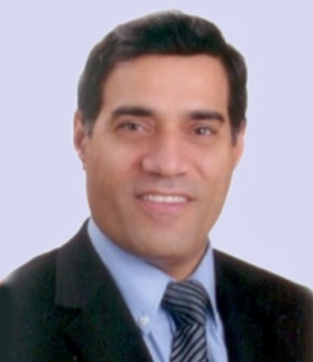
Dr. Sami Salem Ahmad ( C.V)

Consultant Surgeon for Gastrointestinal and Obesity Surgery
Med. State Exam/Hamburg
PhD, FRCS, Facharzt,
Present
Director of The Department of Gastrointestinal and Obesity Surgery@Universal Hospital Abu Dhabi, Consultant Surgeon@ medical Center/Jordan Hospital
1982-1988 Medical school / Hamburg Eppendorf, Germany
1988-1994 Surgical Training / Hamburg, Germany
Specialist in General Surgery
1995-2000 Surgeon at Ealing Hospital, Hammersmith Hospital/ London

Since 2000 Consultant Surgeon in Jordan Clinic for Gastrointestinal and
Obesity Surgery Jordan Hospital - Amman
2005-2015 Consultant Surgeon and Manager Of the Center For Morbid Obesity and Gastroesophageal Reflux Surgery, Roserklinik,
Gastriccenter / Stuttgart, Germany
Specialized in Laparoscopic and Morbid obesity Surgery, General and Gastrointestinal Surgery.
Performed a larg number of Gastric Banding, Gastric Bypass, and Sleeve Gastrectomy and Fundoplication operations.
Membership: German Society for Surgery
Royal College of Surgeons, FRCS
Consultant Surgeon, registered in the Specialist Register U.K
IFSO, International Federation for the surgery of Obesity.
German Society for Morbid Obesity Surgery
Member of IASGO
Member of the advisory group for IFSO European Chapter
HAAD license as Consultant Surgeon

