Epidemiology

(Theme: Co evolving pathogens current challenges and Control measures

About the Conference:
Epidemiology 2015 welcomes attendees, presenters, and exhibitors from all over the world to Valencia, Spain. We are delighted to invite you all to attend and register for the ‘3rd International conference on Epidemiology and emerging diseases (Epidemiology 2015)’ which is going to be held during August 04-06th in Valencia, Spain.
The organizing committee is gearing up for an exciting and informative conference program including plenary lectures, symposia, workshops on a variety of topics, poster presentations and various programs for participants from all over the world. We invite you to join us at the Epidemiology-2015, where you will be sure to have a meaningful experience with scholars from around the world. All members of the Epidemiology-2015 organizing committee look forward to meeting you in Valencia, Spain.
For more details please visit- http://advertising-marketing.conferenceseries.com/

Importance & Scope:
Epidemiological surveillance is conducted all over to investigate the etiological factors of disease and causes for spreading and its preventive measures. This conference provides the global platform for the current research on emerging and reemerging diseases like Ebola, Aids etc. This conference has scope to provide the epidemiological factors like origin, spread and current status of different diseases and disorders causing deaths in different countries.
It also covers emerging and reemerging diseases current research which would be helpful for the industries and students and provides global identification of their research for researchers.

Why Valencia?
Valencia enjoyed strong economic growth over the last decade, much of it spurred by tourism and the construction industry. Many local landmarks were restored, including the ancient Towers of the medieval city (Serrano Towers and Quart Towers), and the San Miguel de los Reyes monastery which now holds a conservation library. The city has numerous convention centres and venues for trade events, among them the Feria Valencia Convention and Exhibition Centre (Institución Ferial de Valencia) and the Palau de congres (Conference Palace), and several 5-star hotels to accommodate business travellers.
Valencia is one of Spain’s largest cities, and a major centre of economy and industry. Its port, El Grao, is one of the busiest on the Mediterranean coast. The main exports from the city are food and drink (mainly wine, oranges, lemons and rice), furniture, ceramic tiles, fans, textiles and iron products. The city is an important centre for the marketing of agricultural and horticultural produce, especially fruit, most of it flowing into the city from the surrounding region. Valencia itself is a manufacturing centre that focuses on metallurgy, chemicals, textiles, shipbuilding and brewing.
The port of Valencia, which handles 20% of Spain’s exports, is the country’s biggest port for container traffic. Extensive renovations have been completed and ambitious expansion projects are under way. From mid the Eighties, with the entrance of Spain in the European Community, the flow of immigrants has experienced a remarkable and progressive growth. In those same dates a qualitative change in the type of immigration begins to take place, sending the European presence and increasing coming from Africa and Latin America.

Conference Highlights:
- Viral infections, global emergence and reemergence
- Bacterial and fungal infections, therapeutic resistance
- Study of non-communicable diseases
- Statistical models and global disease surveillance
- Genetic epidemiology
- Occupational epidemiology and risk factors
- Sexual and reproductive health
- Environmental epidemiology
- Social epidemiology
- Psychiatric epidemiology

Who can attend the Conference?

- Professors, Associate Professors, Assistant Professors
- PhD Scholars
- Graduates and Post Graduates
- Directors, CEO’s of Organizations
- Association, Association presidents and professionals
- Noble laureates in Health Care and Medicine
- Research Institutes and members

Major Epidemiological Associations around the Globe
International Epidemiological association(IEA)
American Society of Epidemiology
American Heart Association Council on Epidemiology and Prevention
Association for Professionals in Infection Control Control and Epidemiology, Inc.
Canadian Society for Epidemiology and Biostatistics

Major Epidemiological Associations in Europe
Spanish society for epidemiology
European Epidemiology Federation
International Genetic Epidemiology Society
Netherlands Epidemiological Society

Statistical Analysis of Associations
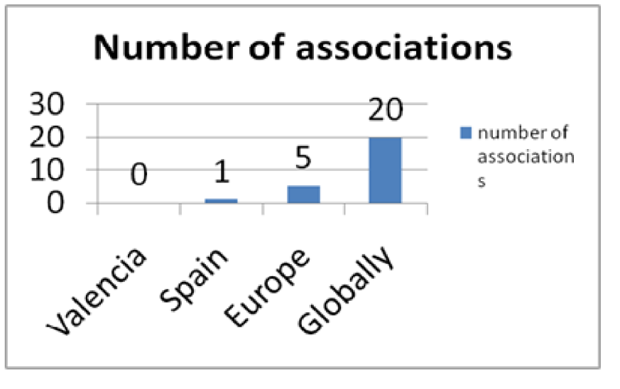

Figure 1: Statistical Analysis
There is 1 Epidemiological association (Spanish society of Epidemiology) in Spain and 5 in Europe and 20 associations globally.

Universities in Spain:

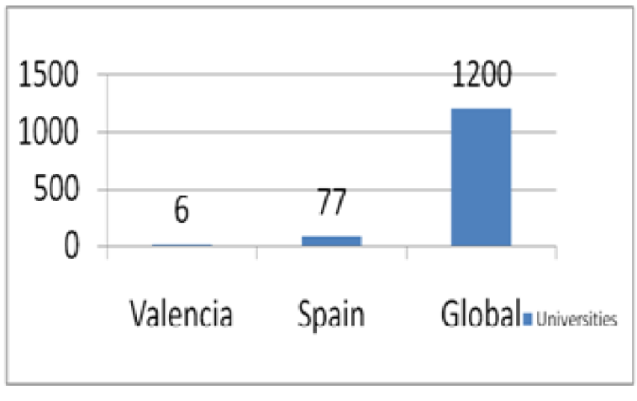

Figure 2: Top Universities in Spain
There are 6 universities in Valencia and 77 universities in Spain and more than 1200 universities globally having epidemiological study.

Hospitals Associated with Epidemiology and Research

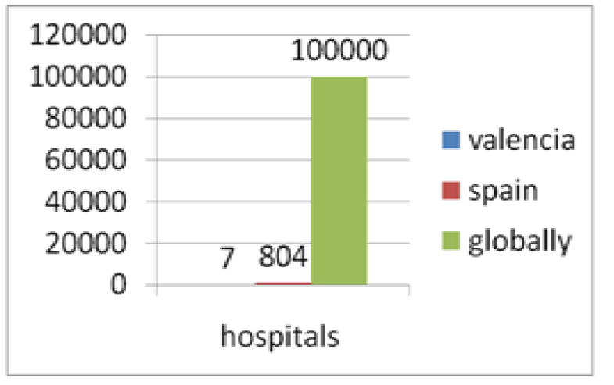

Figure 3: Hospitals Associated with Epidemiology and Research
Source: Reference

There are 7 hospitals in Valencia and 804 hospitals in Spain and more than one lac hospitals globally doing epidemiological and emerging diseases research.

Industrial position of Spain
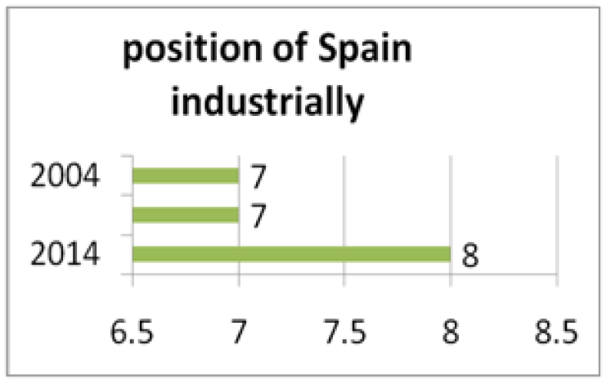

Figure 5: Industrial position of Spain
Source: Reference1
Industrially Spain is in 7th position from 2004-2014, it stands in 8th position in 2014.

Growth of research and Sales:

Statistics which shows growth in importance of research
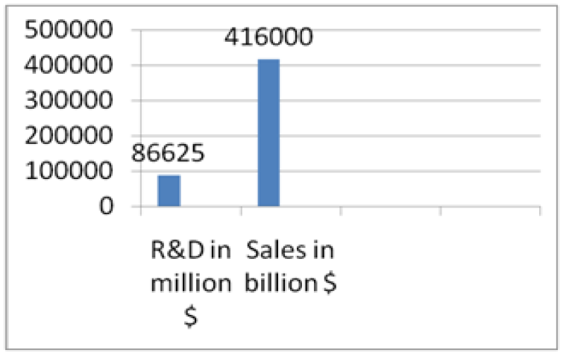

Figure 6: investment and profit on research and sales

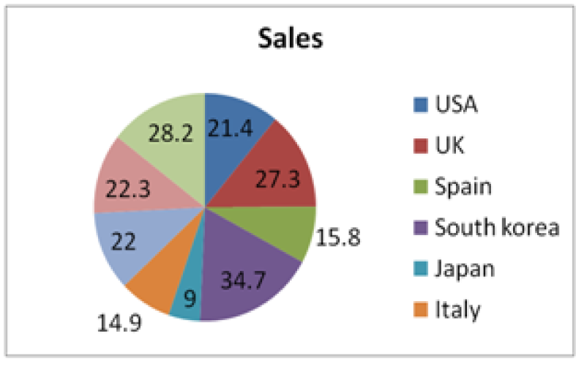
Spain conquered 7th position in drug sales globally.
Figure 7: Share of Global Drug market
Source: Reference

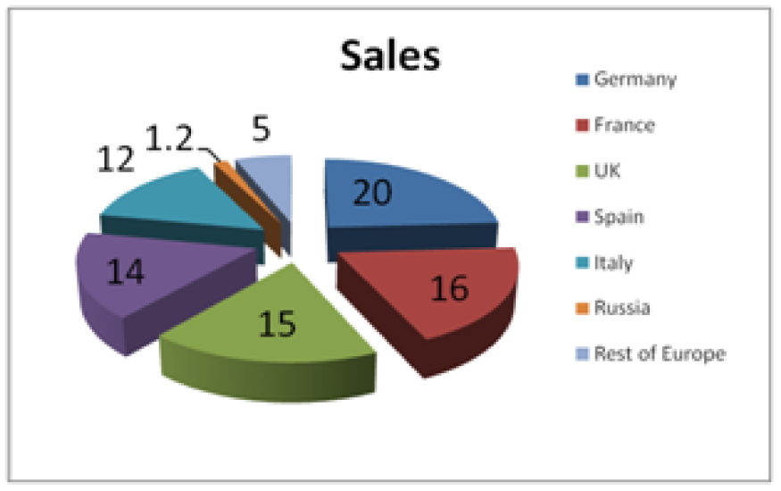

Figure 8: European market share of spain
Spain conquered 4th position in drug market in Europe.

References:
- http://www.reportlinker.com/ci02261/Generic-Drug.html
- http://www.marketsandmarkets.com/Market-Reports/european-injectable-drug-delivery-market-1205.html
- http://en.wikipedia.org/wiki/List_of_hospitals_in_Spain
- http://pharmaboardroom.com/country_reports/spain

