Biomechanics 2015

(Theme: Novel approaches in biomechanics and innovative methods in implant designing)

About the Conference:
Biomechanics-2015 welcomes attendees, presenters, and exhibitors from all over the world to Orlando, Florida U.S. We are delighted to invite you all to attend and register for the “International Conference and Expo on Biomechanics and Implant Design (Biomechanics-2015)” which is going to be held during July 27-29, 2015 in Orlando, Florida U.S.A.
The organizing committee is gearing up for an exciting and informative conference program including plenary lectures, symposia, workshops on a variety of topics, poster presentations and various programs for participants from all over the world. We invite you to join us at the Biomechanics-2015, where you will be sure to have a meaningful experience with scholars from around the world. All members of the Biomechanics-2015 organizing committee look forward to meeting you in Florida, U.S.A.
For more details please visit-http://biomechanics-implantdesign.conferenceseries.com

Importance & Scope:
Biomechanics means implementation of mechanics on biological system. Implant are made for different type of transplantation : Auto/ Allo/ Xeno/ Artificial-Grafts. Biomechanics is not only limited to implant design but its study is necessary for …
- Orthopedics (and surgery)
- Tissue Engineering
- Bones, muscles and ligament mechanics and their manipulation
- Neuro-biomechanics
- Dental implants
- Understanding musculoskeletal biomechanics, gait balancing and body posture
- Bio-, micro-, nano-, composite- and smart- Biomaterials for implant design
- Soft tissue Biomechanics
- Humanoid robots
- Drug designing
Most aspects of business depend on successful marketing. The overall marketing umbrella covers advertising, public relations, promotions and sales. Marketing is a process by which a product or service is introduced and promoted to potential customers. Biomechanics-2015 aims to bring together leading academic scientists, researchers and research scholars to exchange and share their experiences and research results about all aspects of Biomechanics and Implant Design. It also provides the chance for researchers, practitioners and educators to present and discuss the most recent innovations, trends, and concerns, practical challenges encountered and the solutions adopted in the fields of Biomechanics and Implant Design.
Biomechanics-2015 is an international platform for presenting research about biomechanics, exchanging ideas about it and thus, contributes to the dissemination of knowledge in marketing for the benefit of both the academia and business. Biomechanics-2015 is where the future of Biomechanics and Implant Design. This event brings together senior eminent scientists, innovators and agency executives to explore biomechanical and implant designing opportunities on emerging digital media platforms. Biomechanics-2015 is where researchers go to gain perspective on the latest platforms, media models, emerging start-ups, and opportunities that will drive the future of the biomechanical landscape. We bring together research, business, creative, and technology leaders from the bio-mechanical engineering, medical (orthopedics, kinesiology, arthrology, physical medicine, sports science etc.) and implant designing industry for the most current and relevant.

Why Orlando (Florida)?
The Orlando area is one of the leading tourism destinations in the world. The Orlando area is home to Walt Disney World Resort, Universal Orlando Resort, and SeaWorld Orlando. Orlando has the most hotels, and the second largest number of hotel rooms in the country (after Las Vegas, Nevada), and is one of the busiest American cities for conferences and conventions. Orlando offers several 4 Star hotels throughout the market. The newest luxury hotel to open in Orlando is the Waldorf Astoria-Orlando,
Orlando is a major industrial and hi-tech center. The metro area has a $13.4 billion technology industry employing 53,000 people and is a nationally recognized cluster of innovation in digital media, agricultural technology, aviation, aerospace, and software design. More than 150 international companies, representing approximately 20 countries, have facilities in Metro Orlando.
Orlando has the 7th largest research park in the country, Central Florida Research Park, with over 1,025 acres (4.15 km2). It is home to over 120 companies, employs more than 8,500 people, and is the hub of the nation’s military simulation and training programs.
Orlando is well connected to every part of the world with major highways, expressways, rails, commuter and high-speed rail, bus and international airport.
Orlando is the center of Universities of Florida and more than 312,216 students attended these institutions.

Conference Highlights:
- Nanomechanical Implant Design
- Soft Tissues, Bones and Ligaments
- Biomechanics of the Human Neromusculoskeletal System
- Biomedical Engineering
- Innovation, Science and Engineering
- Bio-, Micro-, Nano-, Composite and Smart Materials, for implant designs
- Biomechanical testing methods for material properties of biological tissues
- Biomechanical Devices
- Bone replacement
- Cardiovascular Biomechanics
- Sports biomechanics
- Human Body Physiology And Biomechanics
- Arthrology
- Kinesiology
- Organ regeneration and tissue engineering: scaffold, cells and regulators

Why to attend???
Meet Your Target Market With members from around the world focused on learning about Biomechanics and Implant Design, this is your single best opportunity to reach the largest assemblage of participants from the ADHD community. Conduct demonstrations, distribute information, meet with current and potential customers, make a splash with a new product line, and receive name recognition at this 3-day event. World-renowned speakers, the most recent techniques, tactics, and the newest updates in Biomechanics and Implant Design fields are hallmarks of this conference.
A Unique Opportunity for Advertisers and Sponsors at this International event:
http://biomechanics-implantdesign.conferenceseries.com/Sponsorship.pdf

Major Biomechanics Associations around the Globe
The American Society of Biomechanics (ASB)
International Society of Biomechanics (ISB)
Canadian Society for Biomechanics / Société Canadienne de Biomécanique (CSB/SCB)
European Society of Biomechanics (ESB)
International Society of Biomechanics - Footwear (MEA)-USA
International Society of Biomechanics in Sport (ISBS )
Indian Society of Biomechanics (ISB)
German Society of Biomechanics (GSB)
Australian and New Zealand Society of Biomechanics (ANZSB)
Gait and Clinical Movement Analysis Society (GCMAS)
International Society of Electrophysiology and Kinesiology (ISEK)
The British Association of Sport and Exercise Sciences (BASES)
Asian-Pacific Association for Biomechanics (APAB)
United Kingdom Biomechanics Coaching Association (UKBCA)

Target Audience:
Directors/Chair & Research Experts, Departmental Head/ Dean, Vice Presidents/ Directors & Brand Manufacturers/ Marketers of Consumer Products. Retailers, Marketing, Advertising and Promotion Agency Executives, Solution Providers (digital and mobile technology, P-O-P design, retail design, and retail execution), Professors and Students from Academia in the study of Biomechanics and Implant Design filed.

Target Audience:
Industry 55%
Academia 40%
Others 5%
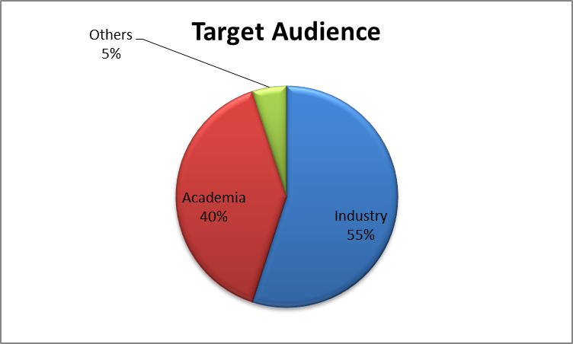

Figure 1: Target Audience

Top Universities in Florida:
University of Florida
University of South Florida
Florida State University
University of Miami
University of Central Florida
Florida International University
Nova Southeastern University
Florida Atlantic University
Embry-Riddle Aeronautical University
Florida Institute of Technology

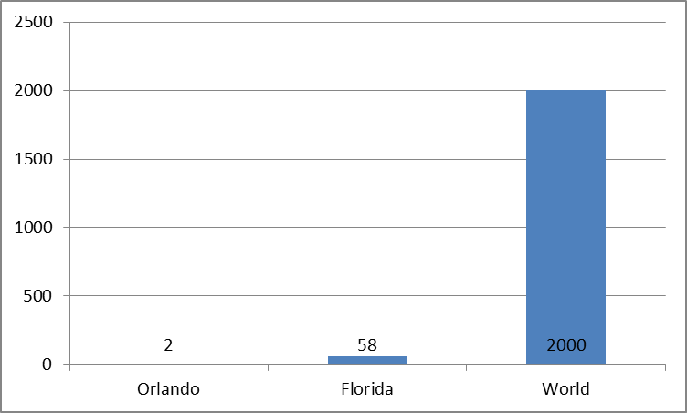

Figure 2: Top Universities in Florida

Source: Reference 1

Companies Associated with Biomechanics and Implant Design

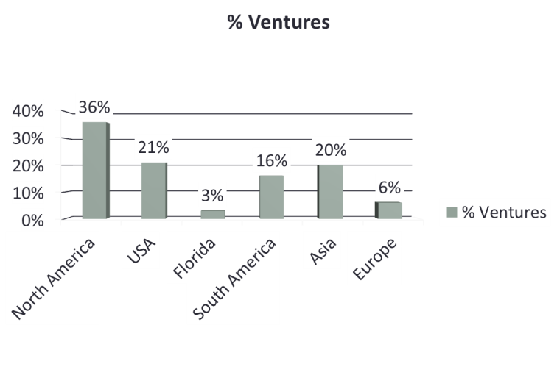

Figure 3: Companies Associated with Biomechanics and Implant Design

Source: Reference 2

Market Growth of Biomechanics and Implant Design

Statistics of Biomechanical Implant Surgery within the US market (Number of surgeries per year)
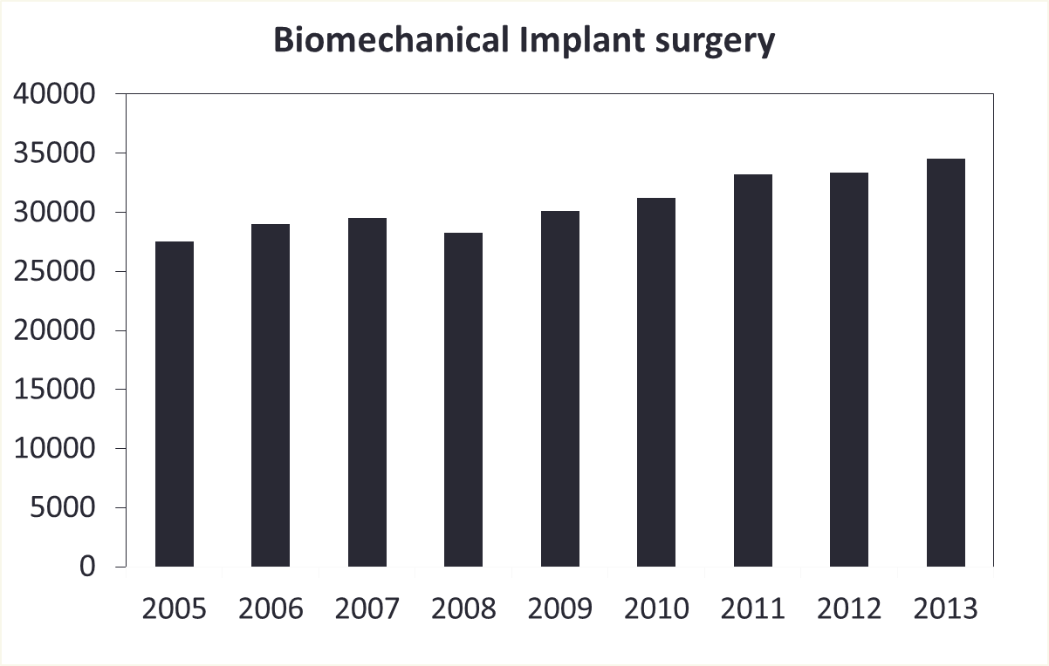

Figure 4: Biomechanical surgery’s trend.

Source: Reference 3
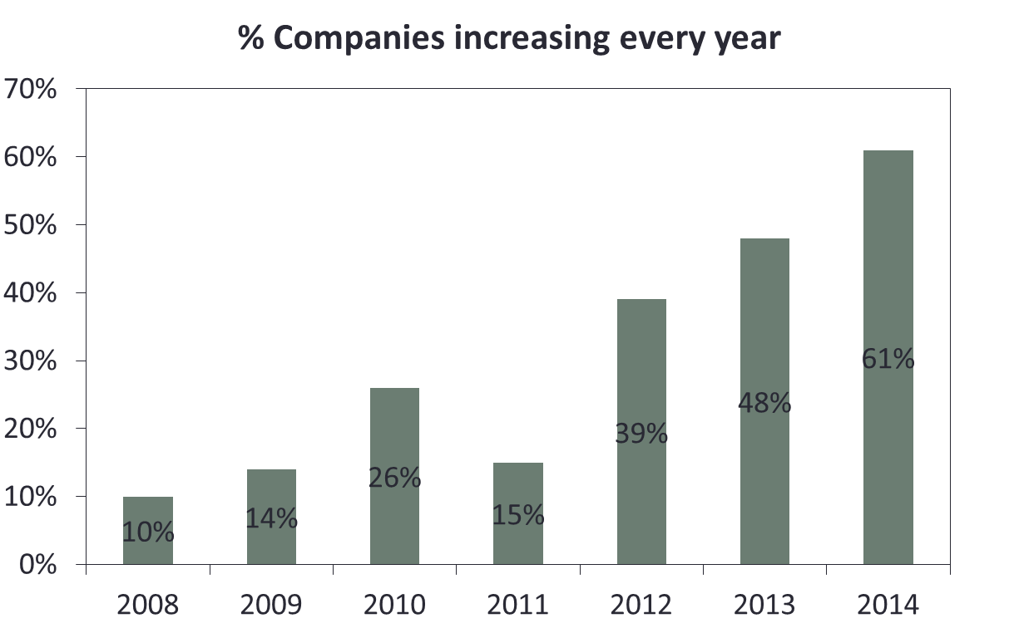

Figure 5: Growth rate of number of companies

Source: Reference 2

Funds allocated by NIDRR, NCMRR, and VA RR&D, for biomechanics related research (million$)
- National Institute on Disability and Rehabilitation Research (NIDRR)
- National Center for Medical Rehabilitation Research (NCMRR)
- Veterans Affairs Rehabilitation Research and Development (VA RR&D)

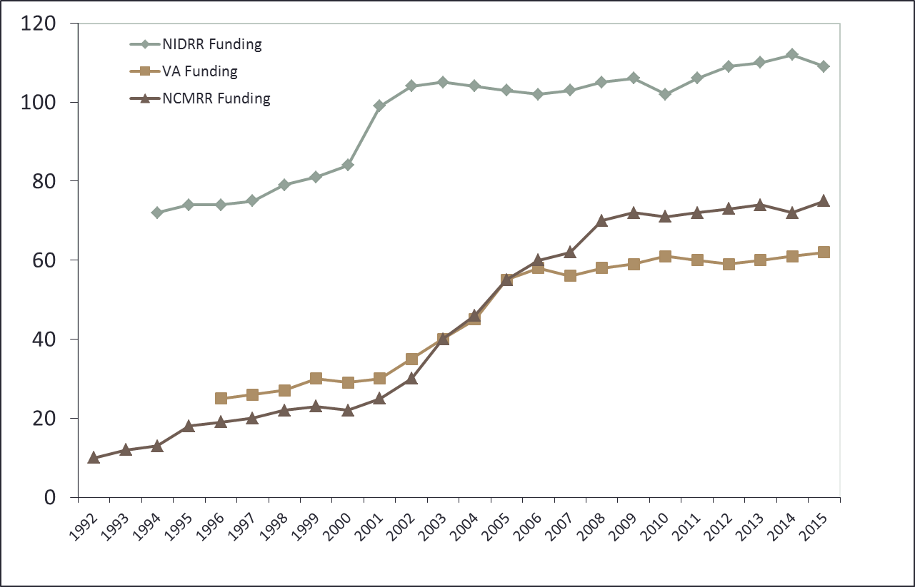

Figure 6: Funds allocation Trend for research and development

Source: Reference 4

Statistics of Researchers and Students in US working on Biomechanics and Implant Design:
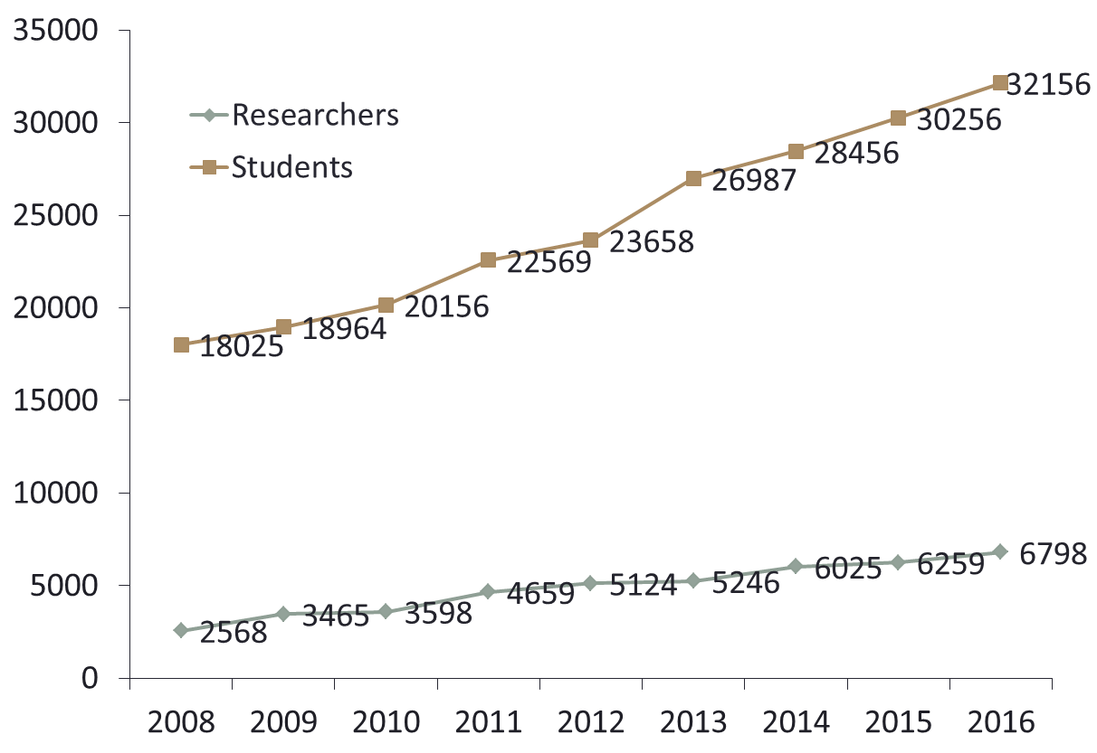

Figure 7: People

Source: Reference 2

References:
- http://www.4icu.org/us/Florida.htm
- http://www.bls.gov/oes/CURRENT/oes172031.htm
- http://www.cdc.gov/nchs/fastats/inpatient-surgery.htm
- http://www.ncbi.nlm.nih.gov/books/NBK11436/figure/a2001315cmmm00011/?report=objectonly

