Wireless Communication

(Theme: Connecting People to Connecting Global)

Summary:
Wireless communications have become essential to the day-to-day lives of the majority of the world's consumers. As a result, demand for the industry has surged with revenue following suit. Over the five years to 2014, revenue is expected to grow an annualized 4.2% to a staggering $1.5 trillion. The topic of Emerging Wireless Technologies and application, Wireless device, Wireless security, Wireless data communication, Wireless network, Wireless sensors, Wireless services, Wireless green communications are the impact on globe for wireless field.
For more details please visit- http://wirelesscommunication.conferenceseries.com/

Importance & Scope:
Wireless Communication is by any measure the fastest emerging segment of the communications industry. As such it has attracted the imagination of public. The convergence of wireless communications is bringing together areas of immense growth and innovation, especially emphasizing multidisciplinary views of communication and networking. This is reflected throughout the globe by strongly focusing on new trends, developments, emerging technologies and new industrial standards.
Wireless Communication-2015 aims to bring together leading academic scientists, researchers and research scholars to exchange and share their experiences and research results about all aspects of Internet Marketing and Advertising. It also provides the chance for researchers, practitioners and educators to present and discuss the most recent innovations, trends, and concerns, practical challenges encountered and the solutions adopted in the fields of Advertising and Marketing.
Wireless Communication-2015 is an international platform for presenting research about marketing, exchanging ideas about it and thus, contributes to the dissemination of knowledge in marketing for the benefit of both the academia and business.
Wireless Communication-2015 is where the future of Advertising and Marketing intersects. This event brings together senior brand marketers and agency executives to explore marketing opportunities on emerging wireless technology. Wireless Communication-2015 is where marketers go to gain perspective on the latest platforms, media models, emerging start-ups, and opportunities that will drive the future of the advertising landscape. We bring together business, creative, and technology leaders from the advertising, marketing, and media industry for the most current and relevant.

Why it’s in Baltimore, USA?
Baltimore is the largest independent city in the United States and the largest city and cultural center of the U.S. state of Maryland. The city is located in central Maryland along the tidal portion of the Patapsco River, an arm of the Chesapeake Bay. Baltimore is sometimes referred to as Baltimore City in order to distinguish it from surrounding Baltimore County. Founded in 1729, Baltimore is a major U.S. seaport and is situated closer to major Midwestern markets than any other major seaport on the East Coast. Baltimore's Inner Harbor was once the second leading port of entry for immigrants to the United States and a major manufacturing center. The harbor is now home to Harbor place, a shopping, entertainment, and tourist center, and the National Aquarium in Baltimore. After a decline in manufacturing, Baltimore shifted to a service-oriented economy. Johns Hopkins University and Johns Hopkins Hospital are now the city's largest employers.
Baltimore is divided officially into nine geographical regions: Northern, Northwestern, Northeastern, Western, Central, Eastern, Southern, Southwestern, and Southeastern, with each patrolled by a respective Baltimore Police Department district. However, it is common for locals to divide the city simply by East or West Baltimore, using Charles Street as a dividing line, and/or into North and South using Baltimore Street as a dividing line.

Why to attend???
- Sign-up to meet the analyst of your choice
- Opportunities to meet with highly qualified peers to validate strategies
- Leading industry speakers and luminaries
- Learn how Wireless Communication - 2015 can help your company with its products and services
- Take advantage of the breadth and depth of content/ issue which helpful.
- Sessions are designed to provide attendees with the latest insights
A Unique Opportunity for Advertisers and Sponsors at this International event:
http://wirelesscommunication.conferenceseries.com/sponsors.php

Major Wireless Communication Associations around the Globe
- Advanced Telecommunications Institute, ATI at Stevens Institute of Technology, Hudson NJ
- Alliance for Competitive Communications
- Alliance for Public Technology (USA)
- American Communication Association
- Centre for International Research on Communication and Information Technologies, CIRCIT (Australia)
- Centre for Wireless Communication at the National University of Singapore
- Communications Research Laboratory of the Ministry of Posts and Telecommunications, Japan
- Competitive Telecommunications Association
- European Organization for Standardizing Information & Communication Systems, ECMA (Switzerland)
- Institute for Telecommunication Sciences (USA)
- Institute of Electronics, Information and Communication Engineers (in English & in Japanese)
- Institute of Telecommunication and Acoustics, ITA (Poland)
- International Interactive Communications Society, IICS USA
- International Mobile Telecommunications Association
- International Multimedia Teleconferencing Consortium
- International Telecommunications Union (Switzerland)
- Pacific Telecommunications Council, PTC
- SINTEF Telecom and Informatics (Norway)
- Society for Technical Communication
- U.S. Federal Communication Commission, FCC
- American Electronics Association
- European Association for Education in Electrical and Information Engineering
- Institute of Electrical & Electronics Engineering, IEEE (USA)

Major Wireless Communication Associations inUSA
- Institute of Electrical & Electronics Engineering, IEEE (USA)
- International Interactive Communications Society, IICS USA
- Institute for Telecommunication Sciences (USA)
- Alliance for Public Technology (USA)

Statistical Analysis of Associations
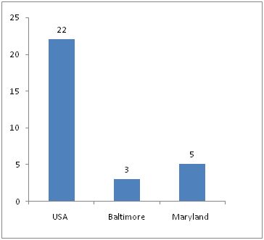

Figure 1: Statistical Analysis
Source reference

Who are attending..?
Professors and Students from Academia in the study of Communication Engineering, Wireless & Telecommunication. Business delegates, Directors / Managers & Business Intelligence Experts, Departmental Managers, Vice Presidents / Directors & Brand Manufacturers Organization related to Wireless Communication & network. More than 6 billion people associated with Communication Engineering in Globe.
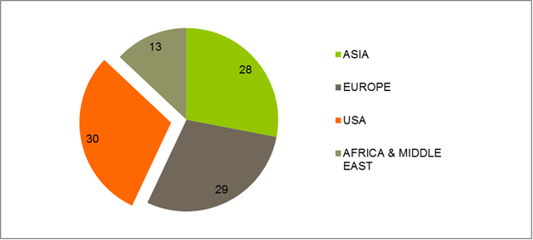

Figure 2: Target Audience
Source: Reference

Top Universities in USA:
- Massachusetts Institute of Technology
- Stanford University
- California Institute of Technology
- Georgia Institute of Technology
- Princeton University
- Cornell University
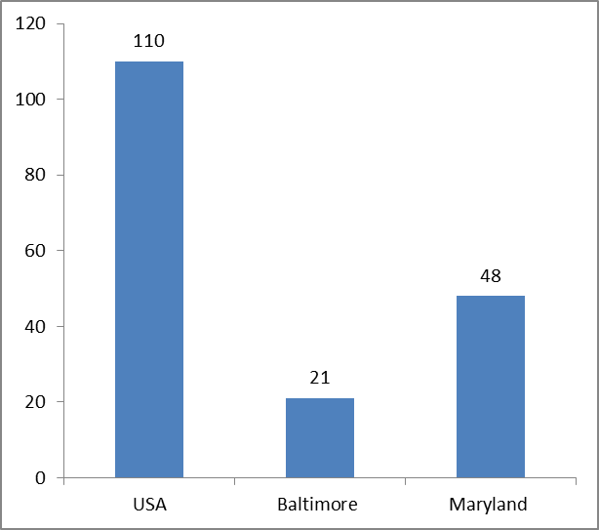
Figure 3: Top Universities in USA
Source: Reference

Companies Associated with Wireless Communication activities
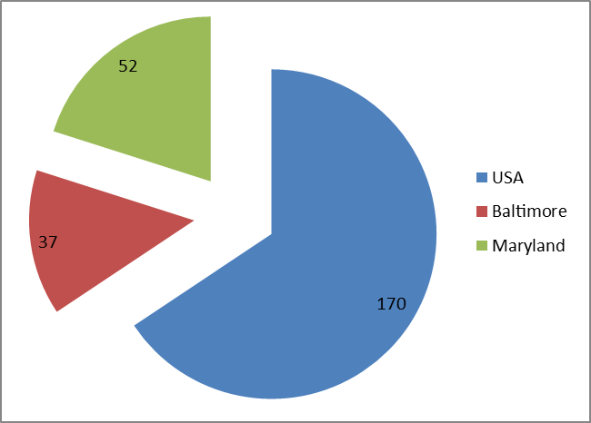
Figure 4: Companies Associated with Wireless Communication
Source: Reference

Global Wireless Market Analysis:
In the past five years, wireless communications have become essential to the day-to-day lives of the majority of the world's consumers. As a result, demand for the industry has surged with revenue following suit. Over the five years to 2014, revenue is expected to grow an annualized 4.2% to a staggering $1.5 trillion. In general, industry firms have adopted two primary strategies to grow revenue: growing subscriber numbers and increasing average revenue per user (ARPU). These strategies are largely dependent on the domestic economies in which firms operate.
In both developed and emerging markets, the Global Wireless Telecommunications Carriers industry is in the growth phase of its lifecycle. Over the 10 years to 2019, industry value added (IVA), which measures the industry's contribution to the global economy, is expected to grow at an annualized rate of 3.6%. In comparison, global GDP is forecast to grow 5.9% per year on average over the same period. Although revenue is still growing in the developed world, growth rates are gradually contracting as markets approach saturation. In contrast, the industry is experiencing double-digit growth in emerging markets as subscriber numbers increase rapidly.
Forecasts the wireless M2M market to account for $196 Billion in revenue by the end of 2020, following a CAGR of 21% during the six year period between 2014 and 2020. This research also indicates that the installed base of LTE powered wireless M2M connections will reach nearly 210 Million by the end of 2020. Eyeing this lucrative opportunity, vendors and service providers across the highly fragmented M2M value chain have become increasing innovative in their strategies and technology offerings which have given rise to a number of submarkets such as M2M network security, Connected Device Platforms (CDP) and M2M application platforms.
Industry Statistics & Forecast: Revenue = $2tr Annual Growth 09-14 = 4.2%

Feature & Opportunity for attendees
- We mean its scope, focus, overall dimensions, and number of speakers, delegates and participants.
- Accelerating the emerging technology in communication engineering.
- Interaction on discussing of fresh issues/innovation.
- B2B meetings for business persons.
- Opportunity to meet other people like business delegates, board of directors, industrial delegates.
- Getting a variety of viewpoints.
- Discuss best practices within the industry.
- Change or improve our own ideas and processes

References:
- http://www.4gamericas.org/index.cfm?fuseaction=page&pageid=565
- http://ieeexplore.ieee.org/Xplore/home.jsp?tag=1
- http://www.4gamericas.org/index.cfm?fuseaction=page&sectionid=262

