Importance of Surgery Conference:
- Surgery is an ancient medical specialty that uses operative manual and instrumental techniques on a patient to investigate and/or treat a pathological condition such as disease or injury, to help improve bodily function or appearance or to repair unwanted ruptured areas.
- Total number of procedures performed in UAE every year is approximately 51.4 million and all over the world are approximately 234 million.
- With new modifications in techniques and drugs, Surgery Conference has become an important convention for doctors and technicians across the world to come together and learn about the advancements.

Importance of Surgery Conference for Universities and Companies:
University
- Provides exposure to the on-going researches in Surgery and related science
- Provides insight to the novel inventions and techniques
- Benefits students and fellowship owners
- Enhances career choices
Companies
- Exhibits novel drugs required in surgeries
- Gives new insight on medical claims, insurance and healthcare services
- Face to face meetings with doctors increase business opportunities

Why Dubai, UAE?
Total numbers of procedures performed are 51.4 million including the number of selected procedures performed:

- Arteriography and angiocardiography using contrast material: 2.4 million
- Cardiac catheterizations: 1.0 million
- Endoscopy of small intestine with or without biopsy: 1.1 million
- Endoscopy of large intestine with or without biopsy: 499,000
- Diagnostic ultrasound: 1.1 million
- Balloon angioplasty of coronary artery or coronary atherectomy: 500,000
- Hysterectomy: 498,000
- Cesarean section:1.3 million
- Reduction of fracture: 671,000
- Insertion of coronary artery stent: 454,000
- Coronary artery bypass graft: 395,000
- Total knee replacement: 719,000
- Total hip replacement: 332,000

The UAE has a life expectancy of 78.4 years at birth, up from 75.2 years in 1990, ranking it 50th among 221 nations. In 2010, coronary artery disease, lung cancer, stroke, chronic obstructive pulmonary diseases, and traffic accidents caused the most years of life lost in the UAE Low back pain, depression, musculoskeletal disorders, neck pain, and anxiety caused the most years lost to disability. The UAE is an upcoming global leader in medical innovation.
As the world’s most advanced cities the health care services in UAE are up-to the mark. All the surveys are conducted under the supervision of Dubai Health Authority (DHA) which is empowered to set and implement the policies and strategies for health. A number of surveys have been conducted contributing in establishing comprehensive health promotion program and chalking out prevention and curative strategies. On 27th June 2010, The Dubai Health Authority (DHA) and Dubai Statistics Centre (DSC) collaboratively completed first most comprehensive Dubai Household Health Survey (DHHS). The Primary Healthcare Services Sector (PHCSS) of Dubai Health Authority (DHA) started a health and Socio-economic survey intended to cover 3,000 families in beginning to understand health issues and risk factors affecting population of Dubai. A survey unveiled that 40% of school children in UAE are overweight and 15% are obese.

Conference Highlights:

- General Surgery and its specialties
- Plastic Surgery
- Ophthalmic Surgery
- Otolaryngology
- Oral Surgery
- Cardiovascular and Thoracic Surgery
- Neurosurgery
- Orthopaedic Surgery
- Obstetrics and Gynaecological Surgery
- Urology
- Transplant Surgery
- Acute Care Surgery
- Perioperative Care and Anaesthesiology
- Advancements in Surgery

Market analysis and scope of Surgery Conference:
- Although being a phenomenal convention, Surgery is quite a difficult conference since surgeons are mostly busy in emergency and annual cases.
- With the introduction of live surgeries, surgeons these days prefer video presentations and live surgery workshops

Surgery Conferences across the World:
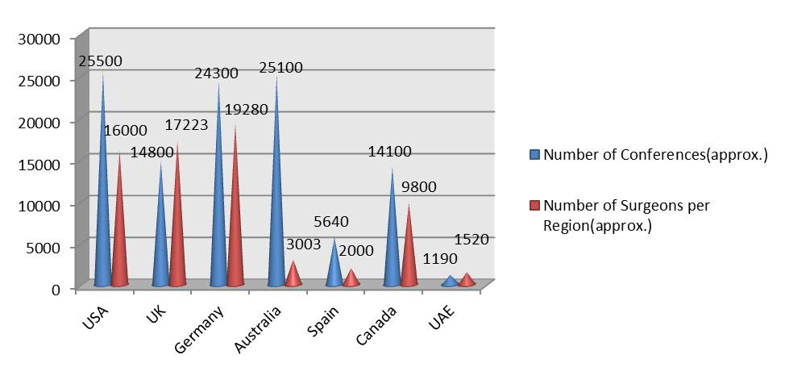
Figure 1: Surgery Conferences across the World
The surgery conferences as seen in the past years have been more in UK, UAE, Germany and USA. When related to the average income of a surgeon in those regions, it is quite possible to find out the potential attendees. An approximate coverage of Surgery conference (in percent):
- USA: 15.71%
- UK: 25.14%
- UAE: 25.45%
- Canada: 12.27%
- Australia: 1.20%
- Germany: 14.49%
- Spain: 5.72%

Number of Surgery Conference per year:
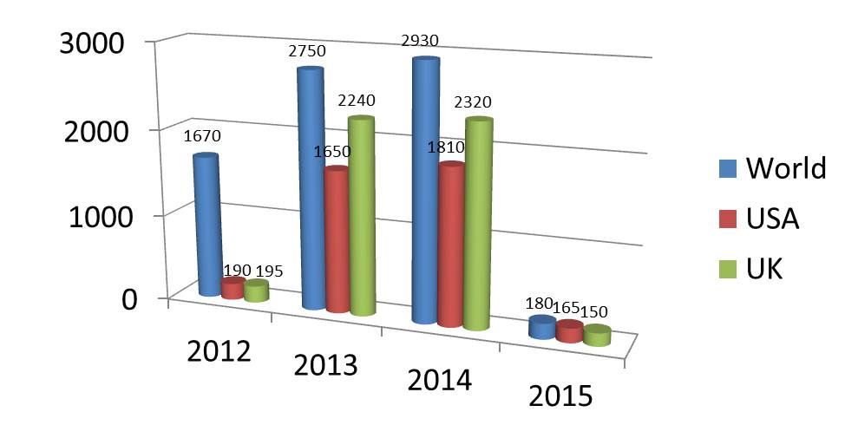
Figure 2: Surgery Conference (per year)
The global surgical market reached $385.5 million in 2012 and $419.7 million in 2013. This market is expected to grow to $631.9 million in 2018, a compound annual growth rate (CAGR) of 8.5% from 2013 to 2018. Just like hospital costs, it’s difficult trying to quantify the costs of a particular surgery, as total payments are often broken down into hospital expenses.
The top three surgical procedures in terms of overall cost were:
- Spinal fusion surgery ($11.26 billion P.A.)
- Angioplasty of the heart ($11 billion P.A.)
- Replacement surgery ($10.36 billion P.A.)

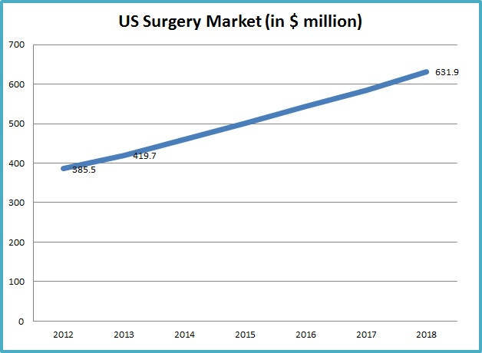

Figure 3: Surgery Market Statistics

Why to attend???
Interaction with members from around the world focused on learning about Surgery and its specialties including Anesthesia, this is the single best opportunity to reach the largest assemblage of participants from over the globe. Conduct demonstrations, distribute information, meet with current and potential customers, make a splash with a new product line, and receive name recognition at this 3-day event. World renowned speakers, the most recent techniques, tactics, and the newest updates in Surgery are hallmarks of this conference.
A Unique Opportunity for Advertisers and Sponsors at this International event: http://surgery.conferenceseries.com/sponsors.php

Target Audience:

- Surgeons
- Anaesthesiologists
- Medical Professors
- Residents
- Fellowship owners
- Medical Students
- Nurses
- Surgical tool technicians
- Pharmaceutical Industries
- Healthcare Industries

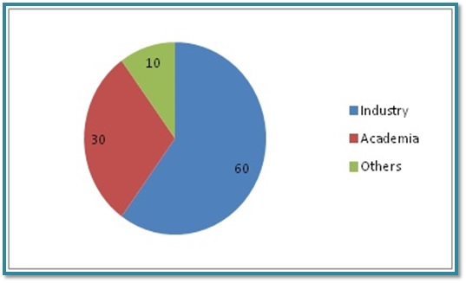

Figure 4: Target Audience
Coverage of Surgery in Middle East:
Universities in Middle East:
- Salman bin abdlaziz university
- Imam Muhammad ibn Saud Islamic University
- King Abdulaziz University
- King Abdulaziz University
- King Saud University
- University of Dammam
- King Faisal University
- King Khalid University
- Taif University
- Al Jouf University
- University of Hail
- Tabuk University
- Faculty of Medicine, University of Aleppo
- Dubai Medical College for Girls
- Gulf Medical University Ajman
- United Arab Emirates University
- University of Sharjah
- Ras al-Khaimah Medical and Health Sciences University
- Aden University
- Sana'a University
- University of Science & Technology
- Thamar University

Universities in UAE:

- Dubai Medical College for Girls
- Gulf Medical University Ajman
- United Arab Emirates University
- University of Sharjah
- Ras al-Khaimah Medical and Health Sciences University
- Aden University
- Salman bin abdlaziz university
- Imam Muhammad ibn Saud Islamic University
- King Abdulaziz University
- King Abdulaziz University
- King Saud University
- University of Dammam
- King Faisal University
- King Khalid University
- Taif University
- Al Jouf University
- University of Hail

Associations across the Globe:

- American Pediatric Surgical Association
- American Shoulder And Elbow Surgeons
- European Surgical Association
- American Society for Reconstructive Microsurgery
- American Society of Transplant Surgeons
- Association of Women Surgeons
- Association for Academic Surgery
- American Society for General Surgeons
- Association for Surgical Education
- Eastern Association for the Surgery of Trauma
- International Society for Heart and Lung Transplantation
- Orthopedic Trauma Association
- Royal College of Physicians and Surgeons of Canada
- Society of University Surgeons
- Southeastern Surgical Congress
- Southwestern Surgical Congress
- Surgical Infection Society
- Women in Neurosurgery
- Women in Thoracic Surgery

Associations in UAE:
- Emirates Medical Association
- Arab Health
- Emirates Plastic Surgery Society
- American British Surgical & Medical Centre, Dubai
- Society of Laparo-endoscopic Surgeons, Inc.
- Society of Thoracic Surgeons

Industries across the Globe:
- Johnson & Johnson
- GE Healthcare
- Siemens Healthcare
- Medtronic
- Baxter International
- Philips Healthcare
- Covidien
- Abbott Labs
- Cardinal Health
- Stryker
- Danaher
- BD
- Boston Scientific
- B. Braun
- Essilor
- St. Jude Medical
- Novartis (Alcon)
- 3M Healthcare
- Zimmer
- Terumo
- Olympus Medical
- Smith & Nephew
- Hospira
- Toshiba Medical
- Getinge Group
- CareFusion
- Bayer
- Fresenius
- C.R. Bard
- Dentsply

Industries in UAE:
- Pfizer UAE
- Johnson & Johnson Middle East
- Merck UAE
- Novo Nordisk Pharma Gulf
- Gulf Pharmaceutical Industry
- Smart Health and Nutrition Ltd.
- Hikma Pharmaceuticals
- Valeant Pharmaceuticals
- Al-Hayat Pharmaceuticals
- Amgen
- Alliance Global
- Sanofi Aventis UAE
- Genpharm
- Ranbaxy Laboratories Limited
- BioPharma
- GlaxoSmithKline
- Gulf Inject
- Global Pharma
- Astra Zeneca UAE
- Neopharma
- Baxter A.G
- Medpharma

References:
- http://www.cdc.gov/nchs/fastats/inpatient-surgery.htm
- http://info.shine.com/
- http://www.debt.org/medical/hospital-surgery-costs/
- http://www.bccresearch.com/
- http://www.pharmacy.org/company.html
- http://forum.thegradcafe.com/

