Oceanography

(Theme: Ocean Science: Understanding its various Processes and Effects)

Summary:
The 3rd International Conference on Oceanography to be held at Philadelphia, USA during June 22-24, 2015 hosted by OMICS Group Conferences through the theme " Ocean Science: Understanding its various Processes and Effects ", conference will explore the advances in Oceanography, Marine Science etc. This conference could be an exceptional event that brings along a novel and International mixture of giant and medium marine research, leading universities and establishments creating the conference an ideal platform to share expertise, foster collaborations across trade and world, and assess rising technologies across the world. OMICS International Publishes 400+ Open access journals which contains over 30000 eminent personalities, reputed scientists as editorial board members and Organizes 300+ Conferences every year across USA, Europe & Asia with support from 1000 more scientific societies.
Oceanography is an interdisciplinary study. It is an amalgamation of several areas of science, and it is commonly diversified as physical, chemical, biological, and geological oceanography. Oceanography-2015 gathers all the extroverts under one roof of current advances.
For more details please visit- http://www.oceanographyconference.com/

Importance & Scope:
Ocean is key to transportation and recreation .Its resources may hold the cures to many diseases. Oceanography study marine life for many different reasons including our consumption, but it studies the tides and currents. Our oceans play a major role in influencing changes in the world's climate and weather.
In recent year’s studies advancements on ocean acidification, ocean heat content, ocean currents, the mapping of methane hydrate deposits, the carbon cycle, coastal erosion, weathering and climate feedbacks in regards to climate change interactions. Oceanography-2015 conference will cover the new research Techniques and concentrates on Exhibition of new Products introduced by the Sea food Laboratories.

Importance of Oceanography in USA
The United States Naval Observatory, were the first to study the marine meteorology, navigation, and charting prevailing winds and currents in 1855.Many nations sent oceanographic observations to the Naval Observatory, where they evaluate the information and distribute the results worldwide. One of every six jobs in the United States is marine-related and over one-third of the U.S. Gross National Product originates in coastal areas. Part of NASA's mission is to develop an understanding of the total Earth system and the effects of natural and human-induced changes on the global environment.
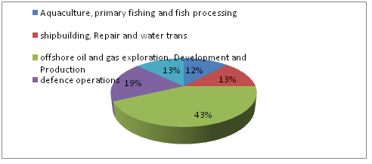

Figure 1: Ocean Technology In USA
Source: Reference4

Conference Highlights:
- Oceanography
- Global Warming and Climate Alteration
- Marine Science and Engineering
- Geological Sciences
- Coastal and Marine Resources: Sustainability
- Renewable Energy Technology associated with Marine Technology
- Pharmacological, Natural and Chemical features
- GIS and Remote Sensing Technology
- Marine Pollution and its Management

Why to attend???
Oceanography-2015 could be an exceptional event that brings along a novel and International mixture of giant and medium marine researchers, leading universities and establishments creating the conference an ideal platform to share expertise, foster collaborations across trade and world, and assess rising technologies across the world. World-renowned speakers, the most recent techniques, tactics, and the newest updates in Oceanography fields are hallmarks of this conference.
A Unique Opportunity for Advertisers and Sponsors at this International event:

http://www.oceanographyconference.com/sponsors.php

Major Oceanography Associations in USA
- Oceanography Society
- National Oceanic and Atmospheric Administration (NOAA)
- Naval Oceanographic Office
- National Council for Science and the Environment (NCSE)
- American Society of Limnology and Oceanography
- Sea Education Association (SEA)
- American Geophysical Union
- Oceanic Society
- Coastal Research and Education Society of Long Island (CRESLI)
- National Association of Marine Laboratories

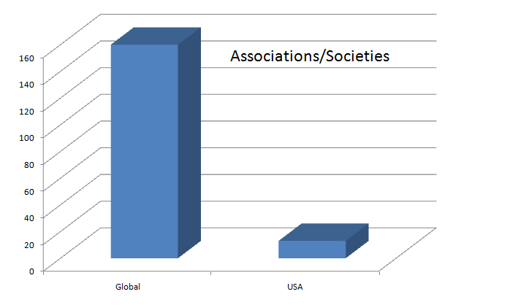

Figure 2: Oceanography Associations and societies in number
Source: Reference3

Target Audience:
Oil and gas companies, shipping companies, sea shore development companies can be invited to attend the conference for a mutual as well as affirmative business discussion and meet. Drug companies for marine herbal products can be called for organizing exhibition. Apart from all this, ocean science researchers and marine biologists shall be listed under invitation.

Oceanography Associated Universities

Top Universities USA
- Woods hole oceanographic institution
- University of Massachusetts, Boston
- Scripps Institution of Oceanography
- University of North Carolina at Wilmington
- Texas A&M University
- University of New Hampshire, School of Marine Science
- University of Alaska Fairbanks
- Virginia Institute of Marine Science VIMS
- University of California-Davis
- University of Maine
- University of California-Santa Barbara
- University of Connecticut
- University of California-Santa Cruz
- University of Colorado (Boulder)
- University of California-San Diego
- University of Delaware, College of Earth, Ocean and Environment
- University of Florida
- University of Washington (Seattle)
- University of Hawaii (Manoa) SOEST
- University of Michigan and Ocean Engineering
- University of Rhode Island
- University of South CarolinaUniversity of South Florida
- University of Southern Mississippi
- University of Texas (Austin)

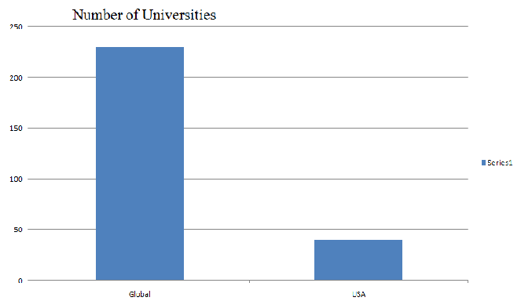

Figure 3: Universities in Number

Market Analysis of Oceanography
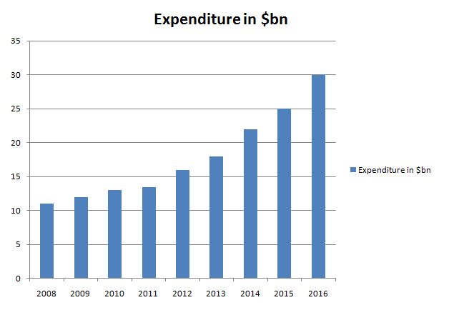

Figure 4: Oceanography Market

References:
- http://www.dmoz.org/Science/Earth_Sciences/Oceanography/Organization
- http://www.ic.gc.ca/eic/site/icoticto.nsf/eng/to00028.html
- http://www.dmoz.org/Science/Earth_Sciences/Oceanography/Organizations/
- http://www.ic.gc.ca/eic/site/icot-icto.nsf/eng/h_to00007.html

