Annual Congress and Medicare Expo on Trauma & Critical Care March 07-09, 2016 Madrid, Spain
Theme: “Understanding Complexities and Evolving Towards a Better Direction in Encountering Emergency Medical Situations”.
Importance & Scope:
The organizing committee is gearing up for an exciting and informative conference program including plenary lectures, symposia, workshops on a variety of topics, poster presentations and various programs for participants from all over the world. We invite you to join us at the Trauma & Critical Care-2016, where you will be sure to have a meaningful experience with scholars from around the world. Conference brings together Eminent Researchers, Business Entrepreneurs and Industry Developers. All members of the Trauma & Critical Care-2016 organizing committee look forward to meeting you in Madrid, Spain. This conference will provide a forum for exchange of ideas and authoritative views by leading scientists as well as business leaders and investors in this exciting field. This creates a relaxed and informal atmosphere with the right settings for meeting new people.
Trauma & Critical Care registries are a potential source of part of the data needed for comprehensive public health surveillance of injuries and all aspects of injury prevention. This conference collects, stores, and retrieves the data describing the etiological factors, demographic characteristics, diagnoses, treatment and clinical outcomes of individuals who meet specified case criteria. This conference provides global platform for current research on practical exposure techniques and guidelines for management and early control of injuries. It would be helpful for the industries and students which provides global identification of their research for researchers.
For more details please visit- http://trauma-criticalcare.annualcongress.com/index.php
Why Madrid?
Madrid is the capital and largest city of Spain. The population of the city is almost 3.2 million and that of the Madrid metropolitan area around 6.3 million. It is the third-largest city in the European Union, after London and Berlin. The city is located on the Manzanares river in the centre of both the country and the Community of Madrid (which comprises the city of Madrid, its conurbation and extended suburbs and villages). Madrid houses the headquarters of the World Tourism Organization (WTO), belonging to the United Nations Organization (UN).
Climate: The Madrid region experiences a Mediterranean climate (Köppen Csa) with continental characteristics, with cool to cold winters due to its altitude of 667 m (2,188 ft) above sea level and distance to the sea, including sporadic snowfalls and minimum temperatures often below freezing. Summers are hot with average July temperatures ranging from 32 to 33°C (90 to 91°F) depending on location. Summer temperatures occasionally climb over 35°C (95°F) during the city’s heat waves. Due to Madrid’s altitude and dry climate, diurnal ranges are often significant during the summer. The highest recorded temperature was on 24 July 1995 with 42.2°C (108.0°F), and the lowest recorded temperature was on 16 January 1945 with −10.1°C (13.8 °F)
Tourist Attraction: While Madrid possesses a modern infrastructure, it has preserved the look and feel of many of its historic neighbourhoods and streets. Its landmarks include the Royal Palace of Madrid; the Royal Theatre with its restored 1850 Opera House; the BuenRetiro Park, founded in 1631; the 19th-century National Library building (founded in 1712) containing some of Spain’s historical archives; a large number of National museums, and the Golden Triangle of Art, located along the Paseo del Prado and comprising three art museums: Prado Museum, the Reina Sofía Museum, a museum of modern art, and the Thyssen-Bornemisza Museum, which completes the shortcomings of the other two museums Cibeles Palace and Fountain have become the monument symbol of the city. Madrid has a considerable number of Catholic churches, famous Almudena Cathedral.
Sports: Madrid is home to two world-famous football clubs, In 1982, Madrid hosted the FIFA World Cup Final. Madrid is one of only four cities in Europe to contain two UEFA 5-star stadia: Real Madrid’s Santiago Bernabéu and Atlético Madrid’s Vicente Calderón Real Madrid and Atlético de Madrid.

Conference Highlights
- Elderly Trauma and critical care
- Paediatric Critical care
- Obstetric Critical care
- Critical Care in Trauma
- Psychological Trauma and critical care
- Blunt trauma
- Intensive Care in Trauma
- Evolution in Emergency Medicine Practices
- New Technology in Trauma Care
- Emergency Medicine and Care Management in Infectious Disease
- Biological need of Trauma
- Trauma-An International Perspective and need for change
- Mass casualties Incident
- Trauma Therapy
- Nursing & Midwifery

Why to attend?
- Opportunity to attend the presentations delivered by Eminent Scientists from all over the world
- Selected contributions will be published in Journal of Emergency Medicine for free of cost
- Best poster presentations and Young scientist awards
- Participation in sessions on specific topics on which the conference is expected to achieve progress
- Global networking: In transferring and exchanging Ideas
- Conference brings together Scientific Researchers & Business Entrepreneurs and Issues in Global Warming and Climate Change
A Unique Opportunity for Advertisers and Sponsors at this International event:

Who can attend the Conference?
- Directors, CEO’s of Organizations
- Association, Association presidents and professionals
- PhD Scholars
- Noble laureates in Health Care and Medicine
- Professors, Associate Professors and Assistant Professors
- Graduates and Post Graduates
- Research Institutes and members

Statistical Analysis of Associations
Target Audience:
Directors/CEO &, Department Head, Vice Presidents/ Directors, Doctors, Surgeons, Nurses, Professors, Students and physicians from Academia in the study of Emergency Medicine filed.
Industry 60%
Academia 30%
Others 10%
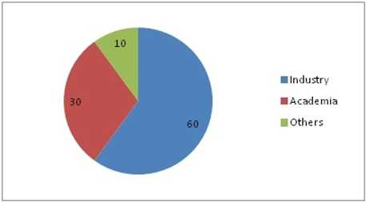
Figure 1: Target Audience

Hospitals Associated with Trauma & Critical Care and Research
There are 14 hospitals in Madrid and 804 hospitals in Spain, in which 308 are Trauma care, Private Hospitals are 465, Ministry of Defence’s Hospitals are 4, National Health System Hospitals are 315 & the hospitals owned by Societies are 20, Europe-6100 and 12000 hospitals globally doing Trauma & Critical Care research.
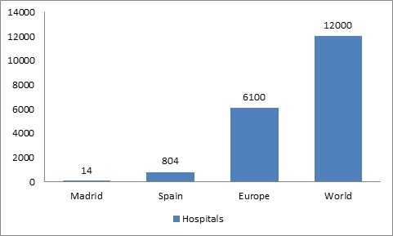
Figure 2: Trauma & Critical Care Associated Hospitals

Major Trauma & Critical Care Associations around the Globe
- American college of Surgeons Committee on Trauma
- International association for trauma surgery and intensive care (IATSIC)
- American Trauma Society
- Trauma Association of Canada (TAC)
- Western Trauma Association (WTA)
- Eastern Association for Surgery of Trauma
- American Association of Orthopaedic Surgeons
- Society of Trauma Nurses
- The United States Army Institute of Surgical research

Major Trauma & Critical Care Associations in Europe
- German society society for trauma surgery (Gsts)
- European Society for Traumatic studies (ESTSS)
- European Society for Trauma & Emergency Surgery (ESTES)
- European Society of Intensive Care Medicine (ESICM)
- Turkish Society for Trauma and Emergency surgery

Universities in Spain:
There are 11 universities, in which 4 were top ranked in Madrid and 81 universities in Spain and more than 22130 universities globally having Trauma & Critical Care study.
- University of Barcelona
- Universidad Autónoma de Madrid
- University Complutense Madrid
- University of Navarra
- Universitat Pompeu Fabra
- Autonomous University of Madrid
- Pablo de Olavide University
- Francisco de Vitoria University
University Statistics
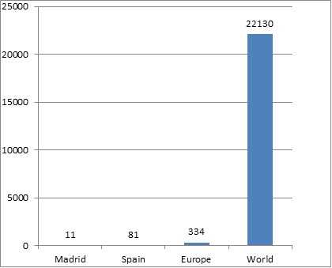
Figure 3: Top Universities in Spain

Growth of research and Sales:
Statistics which shows Market growth in importance of research
Spain has the thirteenth-largest economy by nominal GDP in the world and sixteenth-largest by purchasing power parity. It is the fifth-largest in the European Union, and the fourth-largest in the Eurozone, based on nominal GDP statistics.
Spain is listed 23rd in UN Human Development Index and 30th in GDP per capita by World Bank, thus it is classified as high income economy and among the countries of very high human development. Between 2008 and 2012, the economic boom of the 2000s was reversed. Retail trade sales in Spain showed a gradual decline between 2008 and 2013.
During the economic downturn, Spain has been significantly reducing imports; increasing exports. In 2013 it achieved a trade surplus for the first time in three decades. In their global forecast report from 2014-2016 there was a gradual increase ranging from 0.9% to 2.05%. Spain has gradually become a net contributor of funds for less developed countries of the Union as opposed to receiving funds.
When compared to the world the sales percentage was not constant but in 2008 it showed 1.9%, in 2009 it showed a negative growth and from 2011-2016 the growth rate was increasing and decreasing. Spain has gradually become a net contributor of funds for less developed countries of the Union as opposed to receiving funds.
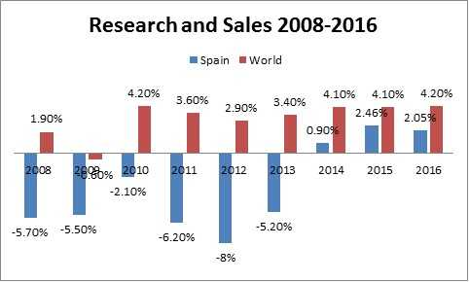
Figure 4: Investment and profit on research and sales

The top five EU nations: the UK, Spain, France, Germany, and Italy accounted for around 60% of the European retail sales through the channel in 2011 and by 2016 it is expected to decline their combined sale between 30-50% and to be overtaken by Russia, which is expected to account for around 30% of total regional sales. Japan and China together account for over two-thirds of total Asia Pacific retail accounting to 5 through 2011. Together, they are expected to share more than three-quarters of the regional online sales by 2016.
Online Retailers in North America accounted for over 40% of the Global sales which include Canada in 2011 and by 2016 its market growth remained same. European Global Online retailers Sales. Asia-Pacific that include Japan and China together account for over two-thirds of total Asia Pacific retail sales making 5% in 2011. Together, they are expected to share more than three-quarters of the regional online sales by 2016.
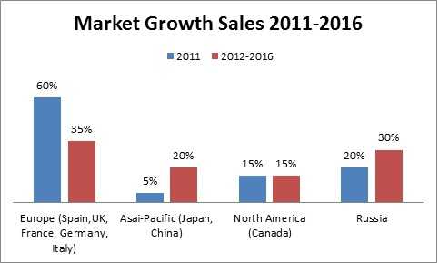
Figure 5: Share of Global market

Statistics of Doctors, Researchers and Academicians working on Trauma
According to the Statistical analysis the number of Professionals working on Trauma research is: There are 800 Doctors working at Madrid, 1773 at Spain and 4250 worldwide.
Researchers at Madrid- 250, Spain-600 and in World-1070 and Academicians at Madrid-390, Spain-810 and Worldwide-1298.
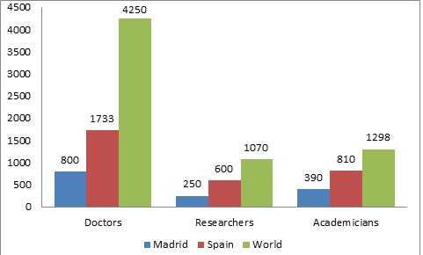
Figure 6. Trauma Doctors-Researchers-Academicians

References:
http://www.trauma.org/archive/webpointers.html
http://en.wikipedia.org/wiki/List_of_hospitals_in_Spain
http://www.topmastersinhealthcare.com/30-most-technologically-advanced-hospitals-in-the-world/
http://hospitals.webometrics.info/en/Europe?page=63
http://www.topuniversities.com/where-to-study/region/europe/top-universities-europe
http://www.temple.edu/medicine/departments_centers/clinical_departments/surgery_trauma_critical_care.http
http://medschool.umaryland.edu/trauma/faculty.asp
http://www.mayoclinic.org/diseases-conditions/post-traumatic-stress-disorder/basics/symptoms/con-20022540
http://www.statista.com/statistics/263610/gross-domestic-product-gdp-growth-in-spain/
http://www.statista.com/statistics/258568/forecast-for-global-retail-sales-growth-by-region/
http://www.marketwired.com/press-release/market-research-forecasts-online-retail-sales-growth-at-15-cagr-through-2016-1676044.htm
http://www.nationaltraumainstitute.org/
https://www.facs.org/search/find-a-surgeon
http://www.aast.org/acs-committee-members
http://www.aast.org/Research/CommitteeMembers.aspx
https://www.facs.org/international/countries
http://www.elmundo.es/grafico/salud/2014/12/05/5481f563268e3efb708b4598.html
http://www.gmc-uk.org/doctors/register/search_stats.asp
http://surgery.ucsd.edu/divisions/trauma-burn/faculty/Pages/default.aspx
https://www.google.co.in/webhp?sourceid=chrome-instant&ion=1&espv=2&ie=UTF-8#q=list+of+trauma+professors+in+world

