About the Conference:
Occupational Health 2016 welcomes attendees, presenters, and exhibitors from all over the world to Toronto, Canada. We are delighted to invite you all to attend and register for the “5thInternational Conference and Exhibition on Occupational Health and Safety (Occupational Health-2016)” which is going to be held during June 06-07, 2016 in Dallas, USA.
The organizing committee is gearing up for an exciting and informative conference program including plenary lectures, symposia, workshops on a variety of topics, poster presentations and various programs for participants from all over the world. We invite you to join us at the Occupational Health-2016, where you will be sure to have a meaningful experience with scholars from around the world. All members of the Occupational Health-2016 organizing committee look forward to meeting you in Toronto, Canada.
For more details please visit- http://occupationalhealth.conferenceseries.com/

Scope & Importance:
Occupational safety and health (OSH) relates to safety health issues at work environment. Occupational health relates to all environmental diseases. It provides that employers maintain plants and systems that are reasonably and practicably safe; they ensure safe methods of handling, storing and transporting materials and also provide adequate induction, training and supervision in those methods. This program area is flexible and suited to both participants attending specific courses related to their immediate needs or those seeking a comprehensive Certificate Program in Occupational Health & Safety Management.
Occupational health will aim for the promotion and maintenance of the highest degree of physical, mental and social well-being of workers in all occupations. Mostly the prevention and protection amongst workers of departures from health caused by their working conditions and their employment from risks resulting from factors adverse to health. The workers in an occupational environment adapted to his physiological and psychological capabilities. The main goal of this program is to provide safety awareness along with demonstration of advance safety equipment’.

Why Dallas?
Dallas is a major city in Texas and is the largest urban center of the fourth most populous metropolitan area in the United States. The city proper ranks ninth in the U.S. and third in Texas after Houston and San Antonio. The city's prominence arose from its historical importance as a center for the oil and cotton industries, and its position along numerous railroad lines. The bulk of the city is in Dallas County, of which it is the county seat; however, sections of the city are located in Collin, Denton, Kaufman, and Rockwall counties.
Dallas is centrally located and within a four-hour flight from most North American destinations. DFW International Airport is the world's fourth busiest airport, offering nearly 1,750 flights per day and providing non-stop service to 145 domestic and 47 international destinations worldwide annually. In addition, Dallas Love Field Airport is conveniently located 10 minutes from downtown. Once here, visitors can ride DART, one of the fastest-growing light rail systems in the nation or the historic, free McKinney Avenue Trolley from the Dallas Arts District throughout the Uptown area with its restaurants, pubs, boutique hotels and shops.
Throughout the city, a visitor will enjoy the best shopping in the southwest, four-and five-diamond/star hotels and restaurants, the largest urban arts district in the nation, 14 entertainment districts and much more. Blend in moderate weather, year-round sports and true Southern hospitality for a true "taste" of the Dallas difference. Visitors are exposed to a city of success ... where optimism meets opportunity. Its pioneering spirit is alive and well, and the philanthropic contributions from its many residents continue to enrich the community and quality of life.

Conference Highlights:
- Women and Occupational Health
- Nano medicine and Safety Issues of Nanotechnology
- Epidemiology and Infectious Diseases
- Occupational Disease and Human Health
- Occupational Medicine and Therapy
- Chronic Health, Industrial Food Safety and Management
- Biotechnology in Health Care
- Agricultural and Environmental Safety
- Construction and Ergonomics
Target Audience:
Professors, Associate Professors, Assistant Professors, PhD Scholars, Graduates and Post Graduates, Directors, CEO’s of Organizations, Association, Association presidents and professionals, Noble laureates in Health Care and Medicine, Research Institutes and members, Supply Chain companies, Manufacturing Companies, Training Institutes, Business Entrepreneurs

Target Audience:
Industry 30%
Academia 60%
Others 10%
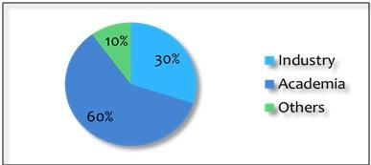

Major Associations around the Globe
- WHO
- American College of Occupational and Environmental Medicine
- Society of Occupational Medicine
- Industrial Hygiene Association
- Alberta Construction Safety Association
- British Safety Industry Federation (BSIF)
- Nova Scotia Construction Safety Association

Major Associations in USA
- American Occupational Therapy Association
- Safety Health Associations
- Occupational Safety and Health Administration
- Central California Safety Council
- Orange County California Association of Occupational Health Nurses
- California State Association of Occupational Health Nurses
Top Universities in USA:
- Princeton University
- Harvard University
- Yale University
- Columbia University
- Stanford University
- University of Chicago
Potential Growth Areas in OHS
- Agriculture, Forestry, and Fishing
- Construction
- Health Care and Social Assistance
- Manufacturing
- Mining
- Oil and Gas Extraction
- Public Safety
- Services
- Transportation, Warehousing, and Utilities
- Wholesale and Retail Trade

Potential Growth Areas in Occupational Health
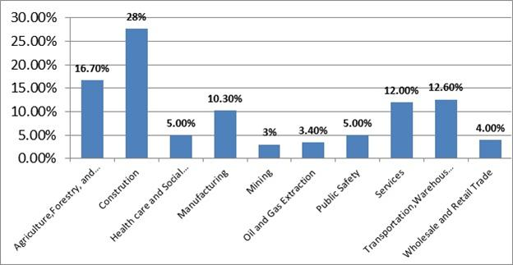

Capital expenditures by sector, by province and territory ($millions)
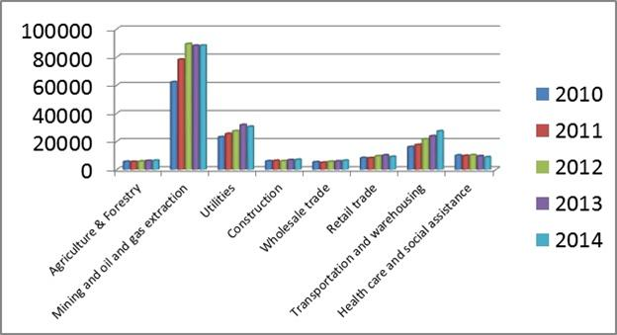

Medicare Home Health and Hospice care Revenue:
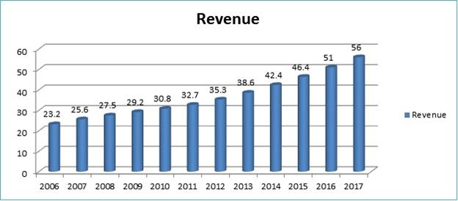
Market Value of Healthcare in USA:
Health care costs continue to rise in the U.S. and throughout the developed world. Total U.S. health care expenditures were estimated to be $3.09 trillion in 2014, and are projected to soar to $3.57 trillion in 2017.The health care market in the U.S. in 2014 included the major categories of hospital care ($959.9 billion), physician and clinical services ($618.5 billion), dental services ($122.4 billion) and prescription drugs ($290.7 billion), along with nursing home and home health care ($248.5 billion). Registered U.S. hospitals totaled 5,723 properties in 2012, according to an American Hospital Association survey, containing 920,829 beds serving 36.1 million admitted patients during the year.
Market Value of Healthcare in World:
Healthcare investment in more than 30 nations including the majority of the world’s most developed economies (but excluding Brazil, Russia, India or China), found stark contrasts between health costs in the United States and those of other nations. In 2012 (the latest complete data available), the average of a list that includes, for example, the UK, France, Germany, Mexico, Canada, South Korea, Japan, Australia and the U.S., spent 9.3% of GDP on health care, unchanged from the previous year. The highest figures in this study were in America at 16.9% of GDP, The Netherlands at 11.9%, France at 11.6%, Switzerland at 11.4%, Germany at 11.3%, Austria at 11.1%, Denmark at 11.0% and Canada at 10.9%.
Growth by next 5-10 years in Worldwide:
The number of seniors covered by Medicare will continue to grow at an exceedingly high rate, from 47.4 million people in 2010 to 81.4 million in 2030. Health informatics industry is expected to reach the value of $6.5 billion by the year 2012 owing to the increase in level of adoption of clinical informatics networks. The number of hospitals adopting the electronic health record (EHR) systems for monitoring and recording the health related data of patients is growing day by day. First being the increasing use of EMRs and EHRs by medical professionals for improving the quality of their services and second being reduction in operating costs of hospitals and related healthcare facilities in near future. The US market for EMRs was estimated at $2.18 billion in 2009 which is forecasted to rise to $6.05 billion by the year 2015 at the compounded annual growth rate of 18.1% during the forecast period from 2010 to 2015.
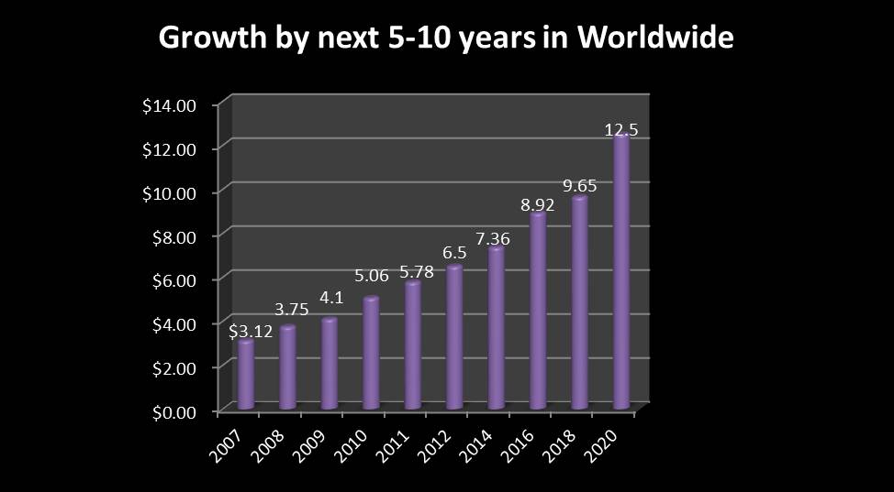
Fund Allotment to Healthcare Research in USA:
The NIH invests nearly $30.3 billion annually in medical research for the American people. More than 80% of the NIH's funding is awarded through almost 50,000 competitive grants to more than 300,000 researchers at more than 2,500 universities, medical schools, and other research institutions in every state and around the world. About 10% of the NIH's budget supports projects conducted by nearly 6,000 scientists in its own laboratories, most of which are on the NIH campus in Bethesda, Maryland.
Fund Allotment to Healthcare Research in World:
The Welcome Trust is the UK's largest non-governmental source of funds for biomedical research and provides over £600 million per year in grants to scientists and funds for research centres. In the United States, in 2003 about 94 billion dollars were provided for biomedical research in the United States. The National Institutes of Health and pharmaceutical companies collectively contribute 26.4 billion dollars and 27.0 billion dollars, respectively, which constitute 28% and 29% of the total, respectively. Other significant contributors include biotechnology companies (17.9 billion dollars, 19% of total), medical device companies (9.2 billion dollars, 10% of total), other federal sources, and state and local governments. Foundations and charities, led by the Bill and Melinda Gates Foundation, contributed about 3% of the funding. In Australia, in 2000/01, about $1.7B was spent on biomedical research, with just under half ($800M, 47%) sourced from the Commonwealth government. About $540M came from business investments/funding and a further $220M from private or not-for-profit organizations (totaling 44%). The balance was from state and local governments. Since then there has been a significant in government funding through the National Health and Medical Research Council (NHMRC), whose expenditure on research was nearly $700 million in 2008–09.
